**Data Conversion of Chia with scope data to .bio files using SpaCy**

Spacy is a library for advanced Natural Language Processing (NLP) in Python and Cython. It has pretrained pipelines and supports tokenization. It includes features like tagging, parsing, Named Entity Recognition, text classification and multi-task learning with pretrained transformers like BERT. In this project we are processing the Chia dataset(https://figshare.com/articles/dataset/Chia_Annotated_Datasets/11855817). It is a large, annotated corpus of clinical trial eligibility criteria.

It also contains 4 configuration files: annotation.conf, kb_shortcuts.conf, tools.conf, visual.conf

**Dataset**: Chia with scope data was considered which contains 4004 files. This dataset includes 12,409 annotated eligibility criteria, represented by 41,487 distinctive entities of 15 entity types and 25,017 relationships of 12 relationship types. There are 4000 files of patient’s data. Each patient is having 4 files in inclusion and exclusion format and with **.ann** and **.txt** file extension. This dataset is divided into 3 parts: train, test, and development. Train dataset consists of 2700 files. Test dataset consists of 700 files. Dev or validation dataset consists of 600 files.

The percentage split is train: test: valid = 80: 10: 10. After the data is arranged properly, download the repository from the GitHub. (<https://github.com/spyysalo/standoff2conll>)

This framework has a python code standoff2conll.py which is useful for conversion from brat-standoff to CoNLL format. Inside the repository place the dataset. The **config.cfg** file defines the training process and pipeline and can be passed to spacy train.

**[paths]**

**train = "training"**

**dev = "validation"**

**vectors = null**

**init_tok2vec = null**

**[system]**

**gpu_allocator = null**

**seed = 0**

**[nlp]**

**lang = "en"**

**pipeline = ["tok2vec","tagger","parser","ner"]**

**batch_size = 1000**

**disabled = []**

**before_creation = null**

**after_creation = null**

**after_pipeline_creation = null**

**tokenizer = {"@tokenizers":"spacy.Tokenizer.v1"}**

**[components]**

**[components.ner]**

**factory = "ner"**

**incorrect_spans_key = null**

**moves = null**

**update_with_oracle_cut_size = 100**

**[components.ner.model]**

**@architectures = "spacy.TransitionBasedParser.v2"**

**state_type = "ner"**

**extra_state_tokens = false**

**hidden_width = 64**

**maxout_pieces = 2**

**use_upper = true**

**nO = null**

**[components.ner.model.tok2vec]**

**@architectures = "spacy.Tok2VecListener.v1"**

**width = ${components.tok2vec.model.encode.width}**

**upstream = "*"**

**[components.parser]**

**source = "en_core_web_sm"**

**replace_listeners = ["model.tok2vec"]**

**[components.tagger]**

**source = "en_core_web_sm"**

**replace_listeners = ["model.tok2vec"]**

**[components.tok2vec]**

**factory = "tok2vec"**

**[components.tok2vec.model]**

**@architectures = "spacy.Tok2Vec.v2"**

**[components.tok2vec.model.embed]**

**@architectures = "spacy.MultiHashEmbed.v1"**

**width = ${components.tok2vec.model.encode.width}**

**attrs = ["NORM","PREFIX","SUFFIX","SHAPE"]**

**rows = [5000,2500,2500,2500]**

**include_static_vectors = false**

**[components.tok2vec.model.encode]**

**@architectures = "spacy.MaxoutWindowEncoder.v2"**

**width = 256**

**depth = 8**

**window_size = 1**

**maxout_pieces = 3**

**[corpora]**

**[corpora.dev]**

**@readers = "spacy.Corpus.v1"**

**path = ${paths.dev}**

**max_length = 0**

**gold_preproc = false**

**limit = 0**

**augmenter = null**

**[corpora.train]**

**@readers = "spacy.Corpus.v1"**

**path = ${paths.train}**

**max_length = 2000**

**gold_preproc = false**

**limit = 0**

**augmenter = null**

**[training]**

**dev_corpus = "corpora.dev"**

**train_corpus = "corpora.train"**

**seed = ${system.seed}**

**gpu_allocator = ${system.gpu_allocator}**

**dropout = 0.1**

**accumulate_gradient = 1**

**patience = 1600**

**max_epochs = 0**

**max_steps = 20000**

**eval_frequency = 200**

**frozen_components = ["tagger","parser"]**

**before_to_disk = null**

**annotating_components = []**

**[training.batcher]**

**@batchers = "spacy.batch_by_words.v1"**

**discard_oversize = false**

**tolerance = 0.2**

**get_length = null**

**[training.batcher.size]**

**@schedules = "compounding.v1"**

**start = 100**

**stop = 1000**

**compound = 1.001**

**t = 0.0**

**[training.logger]**

**@loggers = "spacy.ConsoleLogger.v1"**

**progress_bar = false**

**[training.optimizer]**

**@optimizers = "Adam.v1"**

**beta1 = 0.9**

**beta2 = 0.999**

**L2_is_weight_decay = true**

**L2 = 0.01**

**grad_clip = 1.0**

**use_averages = false**

**eps = 0.00000001**

**learn_rate = 0.001**

**[training.score_weights]**

**tag_acc = 0.33**

**dep_uas = 0.17**

**dep_las = 0.17**

**dep_las_per_type = null**

**sents_p = null**

**sents_r = null**

**sents_f = 0.0**

**ents_f = 0.33**

**ents_p = 0.0**

**ents_r = 0.0**

**ents_per_type = null**

**[pretraining]**

**[initialize]**

**vectors = "en_core_web_lg"**

**init_tok2vec = ${paths.init_tok2vec}**

**vocab_data = null**

**lookups = null**

**before_init = null**

**after_init = null**

**[initialize.components]**

**[initialize.tokenizer]**

**Base_config.cfg**:

# This is an auto-generated partial config. To use it with 'spacy train'

# you can run spacy init fill-config to auto-fill all default settings:

# python -m spacy init fill-config ./base_config.cfg ./config.cfg

[paths]

train = null

dev = null

vectors = null

[system]

gpu_allocator = null

[nlp]

lang = "de"

pipeline = ["tok2vec","ner"]

batch_size = 1000

[components]

[components.tok2vec]

factory = "tok2vec"

[components.tok2vec.model]

@architectures = "spacy.Tok2Vec.v2"

[components.tok2vec.model.embed]

@architectures = "spacy.MultiHashEmbed.v2"

width = ${components.tok2vec.model.encode.width}

attrs = ["ORTH", "SHAPE"]

rows = [5000, 2500]

include_static_vectors = false

[components.tok2vec.model.encode]

@architectures = "spacy.MaxoutWindowEncoder.v2"

width = 96

depth = 4

window_size = 1

maxout_pieces = 3

[components.ner]

factory = "ner"

[components.ner.model]

@architectures = "spacy.TransitionBasedParser.v2"

state_type = "ner"

extra_state_tokens = false

hidden_width = 64

maxout_pieces = 2

use_upper = true

nO = null

[components.ner.model.tok2vec]

@architectures = "spacy.Tok2VecListener.v1"

width = ${components.tok2vec.model.encode.width}

[corpora]

[corpora.train]

@readers = "spacy.Corpus.v1"

path = ${paths.train}

max_length = 0

[corpora.dev]

@readers = "spacy.Corpus.v1"

path = ${paths.dev}

max_length = 0

[training]

dev_corpus = "corpora.dev"

train_corpus = "corpora.train"

[training.optimizer]

@optimizers = "Adam.v1"

[training.batcher]

@batchers = "spacy.batch_by_words.v1"

discard_oversize = false

tolerance = 0.2

[training.batcher.size]

@schedules = "compounding.v1"

start = 100

stop = 1000

compound = 1.001

[initialize]

vectors = ${paths.vectors}

[initialize.lookups]

@misc = "spacy.LookupsDataLoader.v1"

lang = ${nlp.lang}

tables = ["lexeme_norm"]

**Commands used in the SpaCy Project**:

1. Creating a conda environment inside the Virtual Machine

**conda create –name nlp_text_analytics**

2. Activate the newly created conda environment

**conda activate nlp_text_analytics**

3. Upgrade the version of python to python 3.7

**conda install -c anaconda python=3.7**

4. Install the pre-requisites of Spacy

**python -m pip install --upgrade pip --user**

**python -m pip install -U pip setuptools wheel**

**python -m pip install -U spacy==3.1.3**

5. Convert the data present in train, test and dev directories into .bio file

**python3 standoff2conll.py data/train > train.bio**

**python3 standoff2conll.py data/test > test.bio**

**python3 standoff2conll.py data/dev > dev.bio**

It generated train.bio file of 1990KB size, test.bio file of 456 KB size and dev.bio file of 425 KB size.

6. Convert the .bio files into .spacy format. It groups every 10 sentences in a document and generates respective .spacy file

**python -m spacy convert train.bio -c conll ./output/ -n 10**



**python -m spacy convert test.bio -c conll ./output/ -n 10**



**python -m spacy convert dev.bio -c conll ./output/ -n 10**

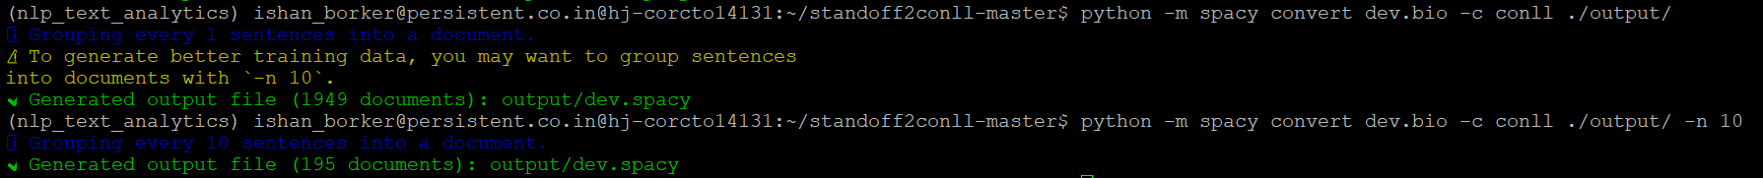

Size: train.spacy is 1093 KB, test.spacy is 270 KB, and dev.spacy is 245 KB.

7. Initialize the config.cfg file.

**python -m spacy init fill-config config.cfg config.cfg**

8. Calculate the training scores of the dataset.

**python -m spacy train config.cfg --paths.train ./output/train.spacy --paths.dev ./output/dev.spacy**

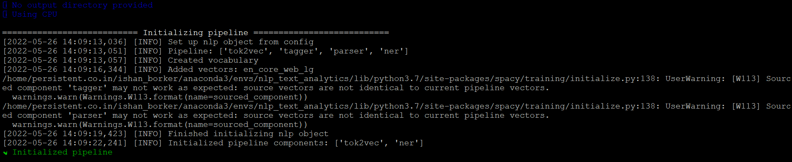

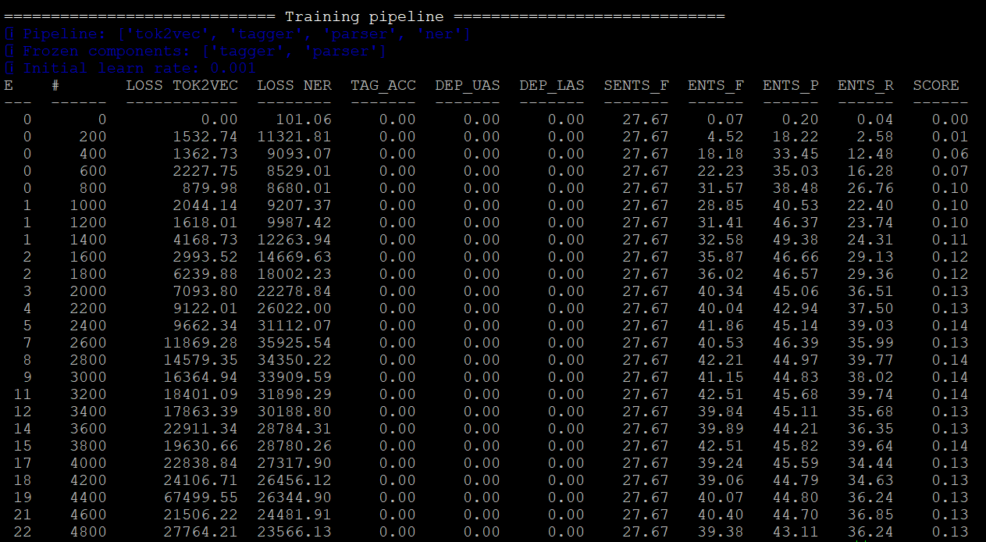

When we initialize the **base_config.cfg** file using the command **python -m spacy init fill-config config.cfg config.cfg** and run the training scores we get the following results:

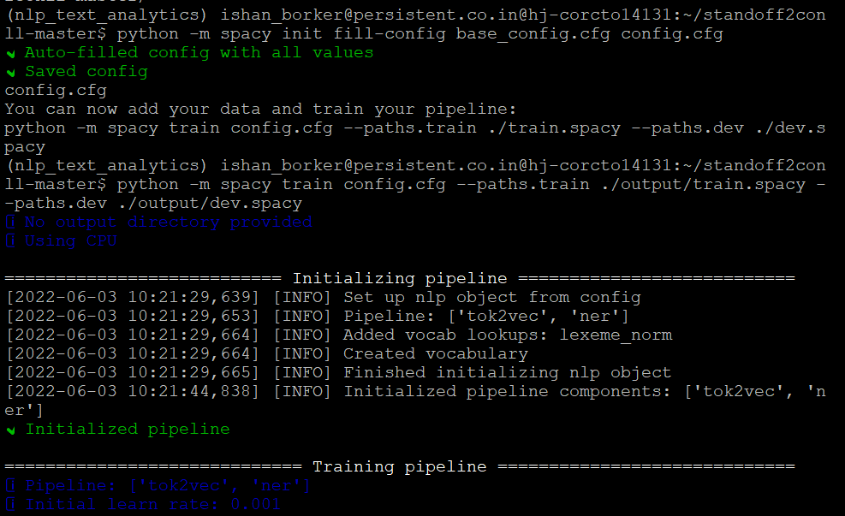

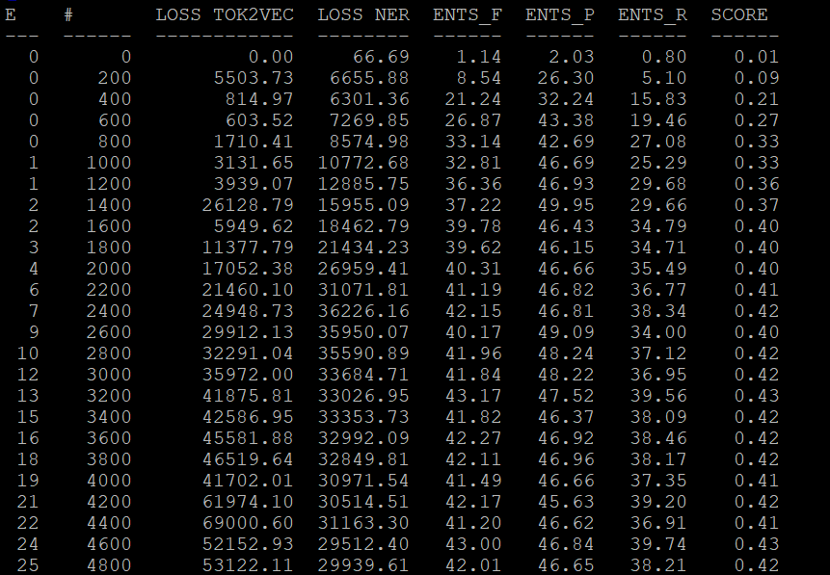

9. Calculate the test scores of the dataset using evaluate command

**python -m spacy evaluate -o ./output/test1.spacy en_core_web_sm ./output/dev.spacy**

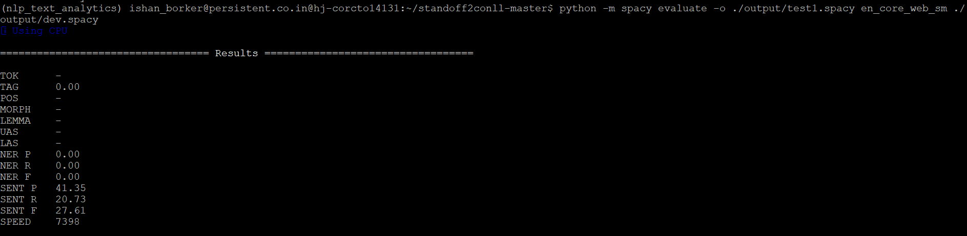

**python -m spacy evaluate -o ./output/test1.spacy en_core_web_sm ./output/train.spacy**

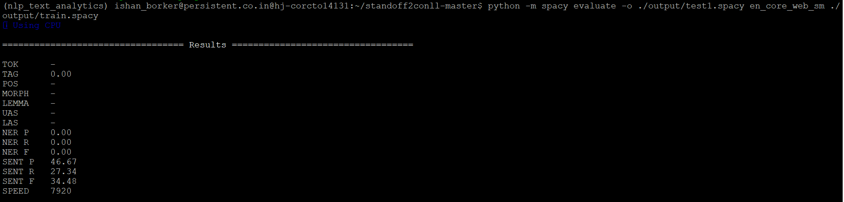

**python -m spacy evaluate -o ./output/test1.spacy en_core_web_sm ./output/test.spacy**

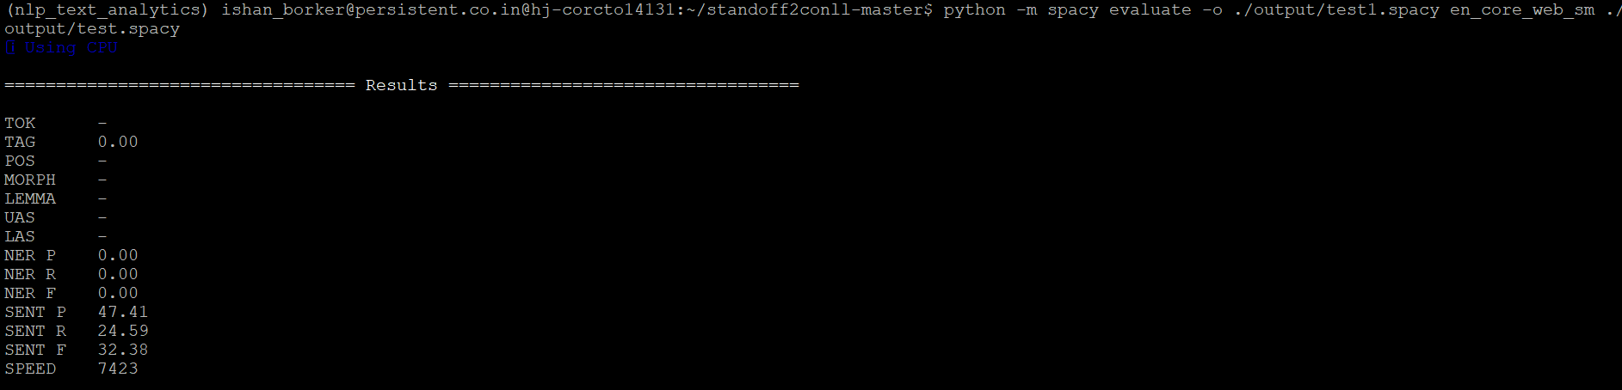

**Results of NER F1 score**

1. The code for **generate_spaCy_data.ipynb** and **TestSpaCyOutput.ipynb** were written inside the Jupyter notebook. (without using standoff2conll repository)
2. In this method a blank English model of spacy was loaded using **nlp = spacy.blank("en")**.
3. Top 10 entities like "Condition", "Scope", "Qualifier", "Value", "Drug", "Procedure", "Measurement", "Temporal", "Observation", "Person" were highlighted from Chia dataset.
4. Missing entities were excluded, and the data was processed for carrying out training using NER.
5. The dataset was then converted to **chia_ner_full.spacy** file.
6. Next, the testing of spacy output was carried out using **docbin=DocBin().**
7. The dataset was split into training, testing and validation (80%, 10%, 10%) respectively using sklearn model selection method and random shuffling method.
8. Dump to disk function was used to save the split dataset into **chia_ner_train.spacy**, **chia_ner_test.spacy** and **chia_ner_dev.spacy**.
9. Traverse to the directory **chia_clinical_trials/projects/tutorials/ner_pytorch_medical**.
10. Inside the repository (**chia_clinical_trials/projects/tutorials/ner_pytorch_medical**), we edit the train, test and dev paths in project.yml file.
11. We use the Chia with scope dataset (both inclusion and exclusion) and place the annotated (.txt) files inside **chia_clinical_trials/projects/tutorials/ner_pytorch_medical/assets** folder.
12. Pipeline used is Pipeline=[‘tok2vec’, ‘ner’].
13. Initialize the **config.cfg** file using the command:

**python -m spacy init fill-config ./configs/config.cfg ./configs/config.cfg**

1. Calculation of the NER F1 scores after proper conversion of .spacy files was carried out inside the CPU using the command:

**python -m spacy train ./configs/config.cfg --paths.train ./corpus/chia_ner_train.spacy --paths.dev ./corpus/chia_ner_dev.spacy**

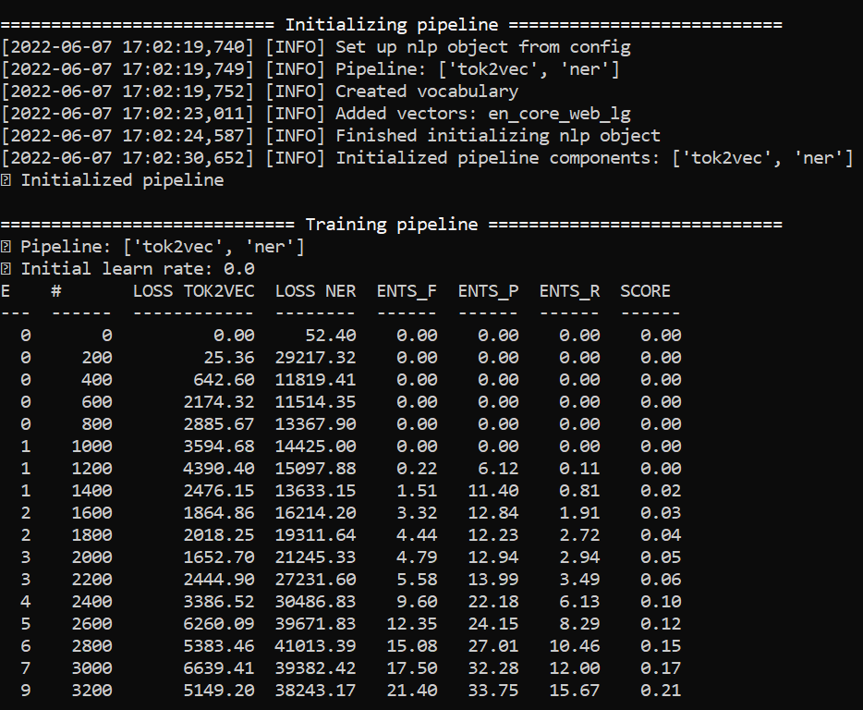

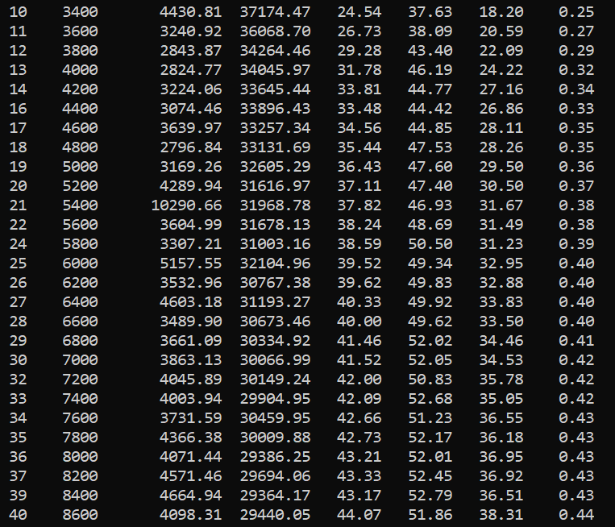

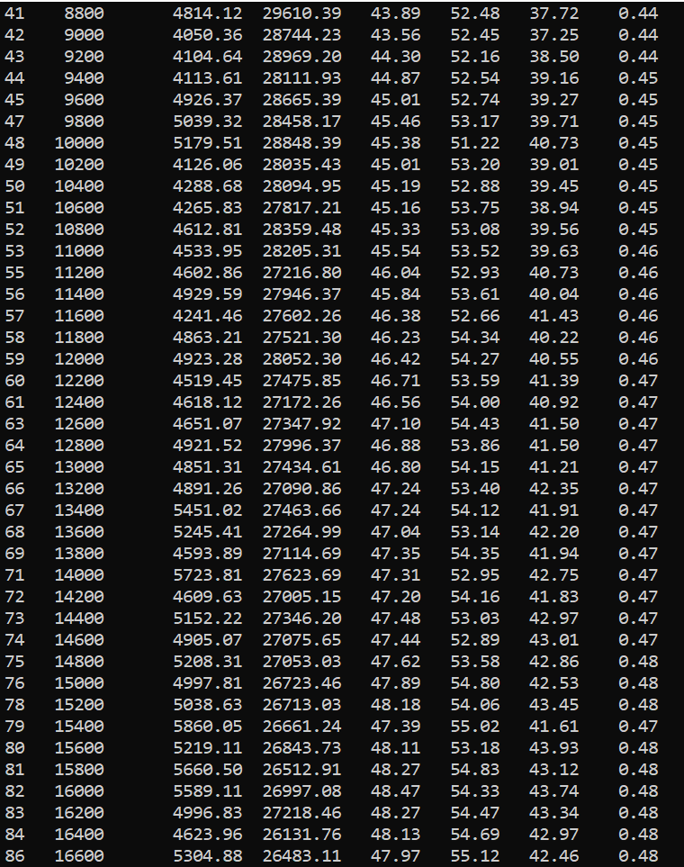

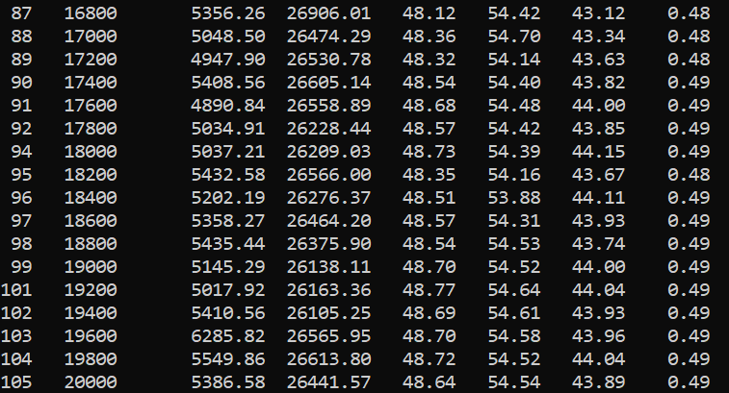

The same results were obtained inside Google Colaboratory for NER using CPU.

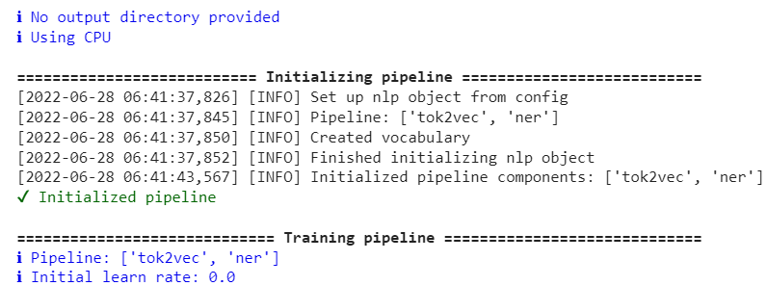

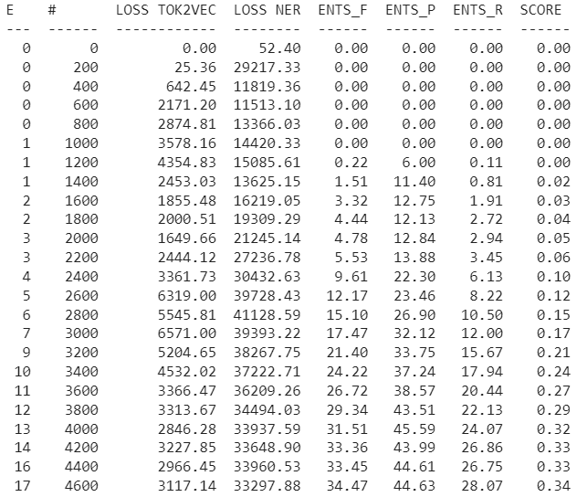

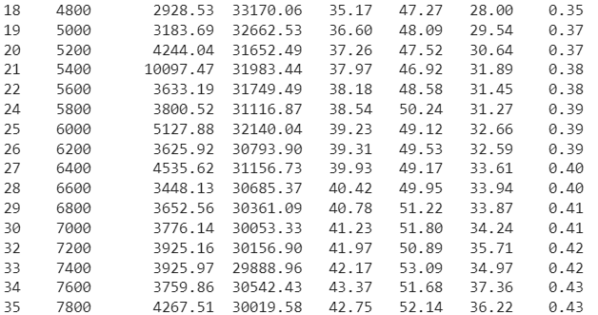

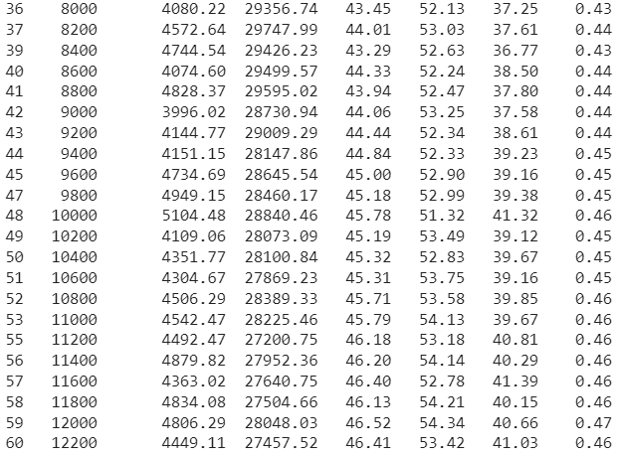

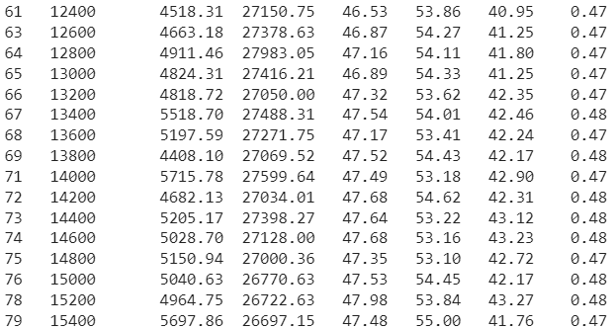

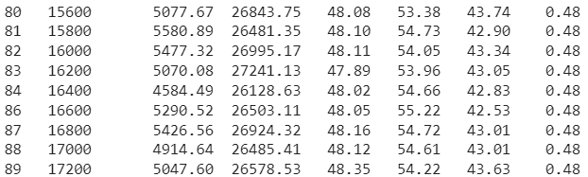

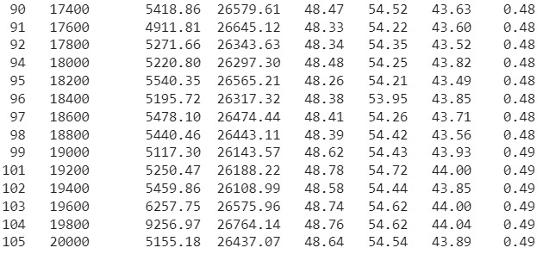

The loss curve plot is as follows:

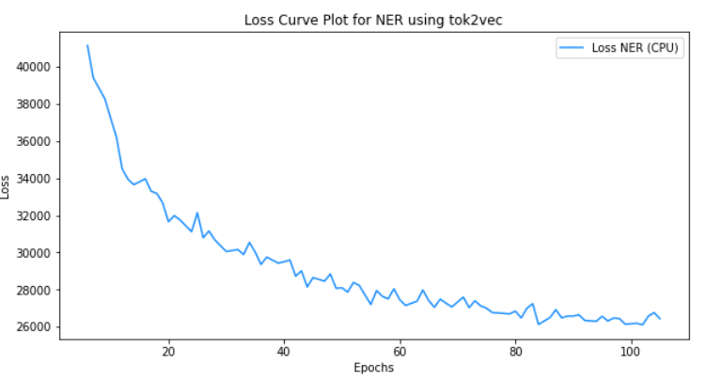

**Approach 2 (Alternative)**:

Entire document was considered during conversion of chia_ner.tsv file to chia_ner.spacy file. Then using random split and using sklearn train test split methods, the chia_ner.spacy file was split into chia_ner.train.spacy, chia_ner_test.spacy and chia_ner_dev.spacy in the ratio 80:10:10.

We then use the train NER command to get the performance metrics of the model using F1 score and save the output in the folder.

**python -m spacy train ./configs/config.cfg --output ./output_tok2vec --paths.train ./corpus/chia_ner_train.spacy --paths.dev ./corpus/chia_ner_dev.spacy**

The results were obtained inside Google Colaboratory for NER using CPU.

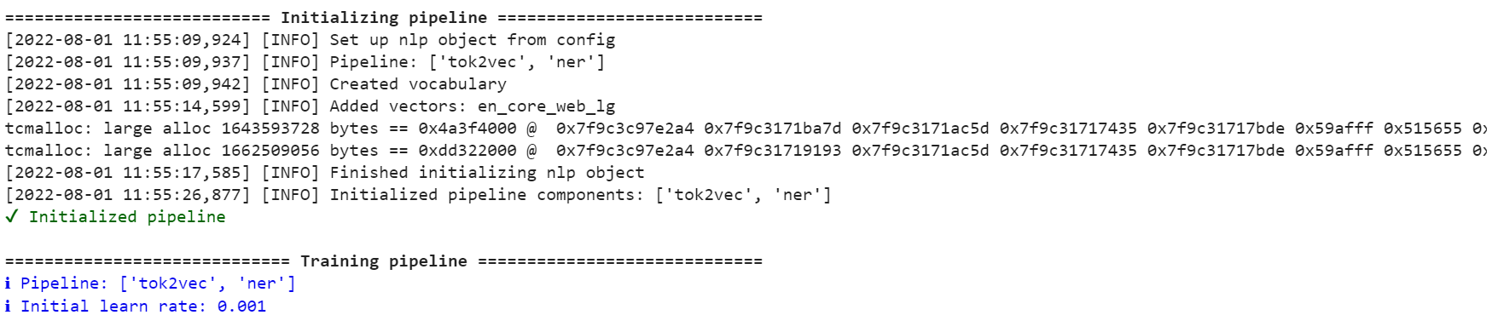

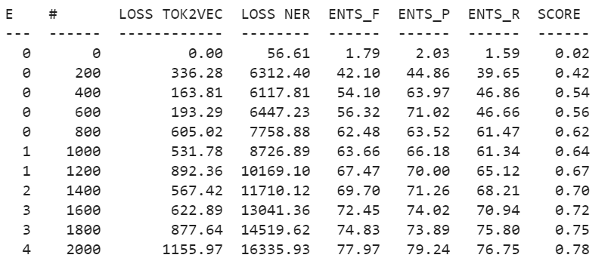

The loss curve plot is as follows:

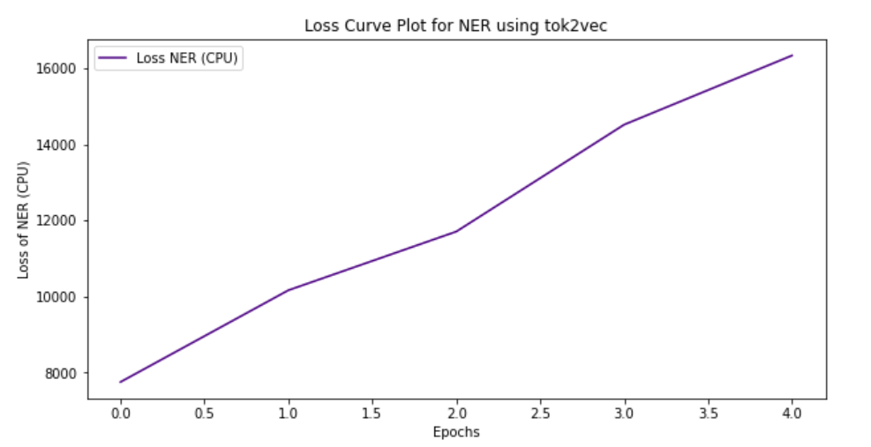

1. Initialize the **config_trf.cfg** file (using transformers).

**python -m spacy init fill-config ./configs/spacy_config_trf.cfg ./configs/config_trf.cfg**

1. Installing spacy transformers: **pip install spacy-transformers**.
2. Pipeline used is Pipeline =[‘transformer’,’ner’].
3. Calculation of the NER F1 scores after proper conversion of .spacy files was carried out using different transformers.
4. Change the name of transformer to ‘**roberta-base**’ inside the config_trf.cfg file present in **/content/drive/MyDrive/chia_clinical_trials/projects/tutorials/ner_pytorch_medical/configs** directory.

**Training on GPU**:

**python -m spacy train ./configs/config_trf.cfg --paths.train ./corpus/chia_ner_train.spacy --paths.dev ./corpus/chia_ner_dev.spacy --gpu-id 0**

The results were obtained inside Google Colaboratory for NER using GPU.

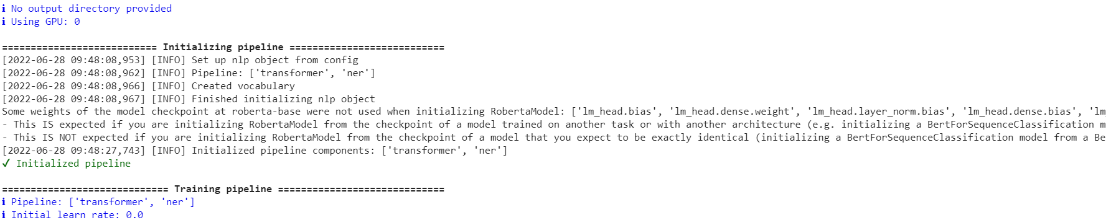

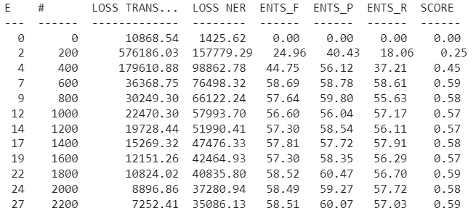

The loss curve plot is as follows:

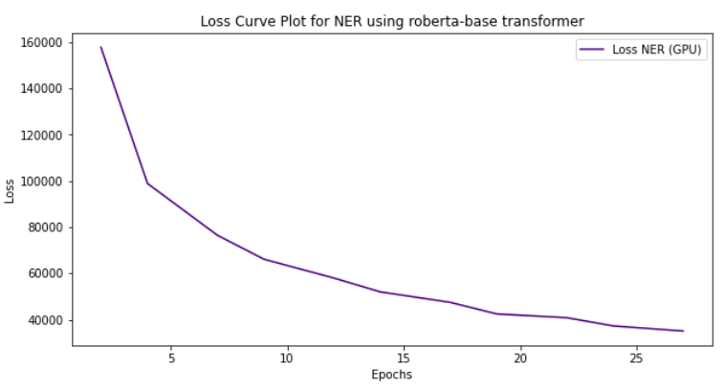

The similar results were obtained after splitting the dataset into train and test in 80:20 ratio.

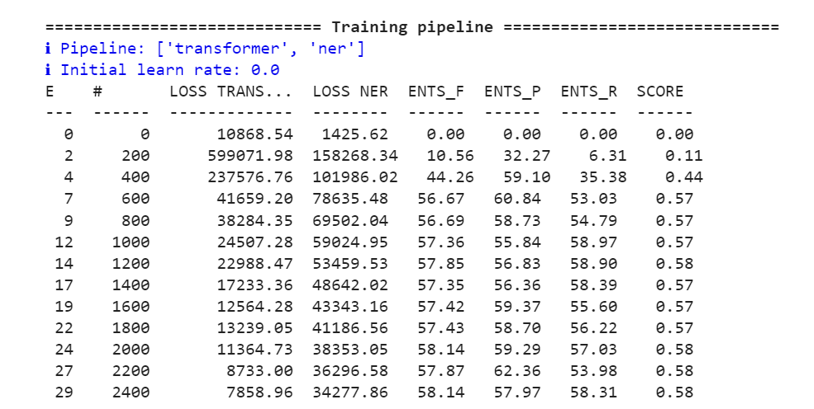

The loss curve plot is as follows:

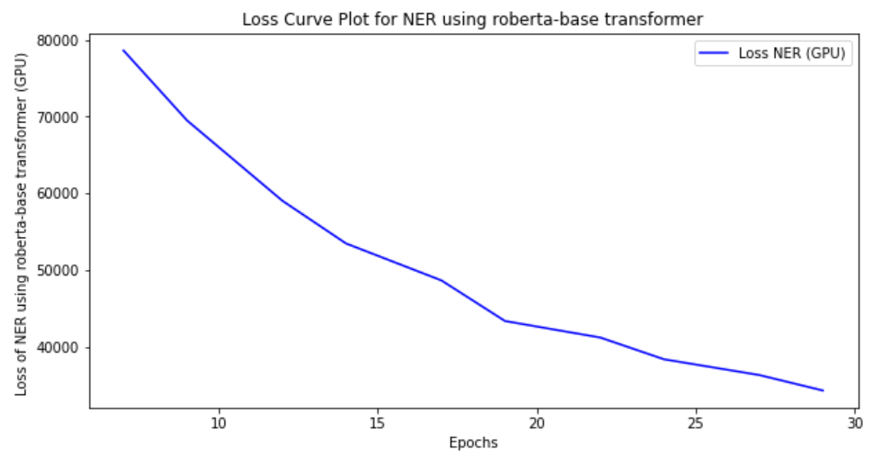

**Approach 2 (Alternative)**:

Use the train command to obtain the performance metrics and save the **output_roberta_base**.

**python -m spacy train ./configs/config_trf.cfg --output ./output_roberta-base --paths.train ./corpus/chia_ner_train.spacy --paths.dev ./corpus/chia_ner_dev.spacy --gpu-id 0**

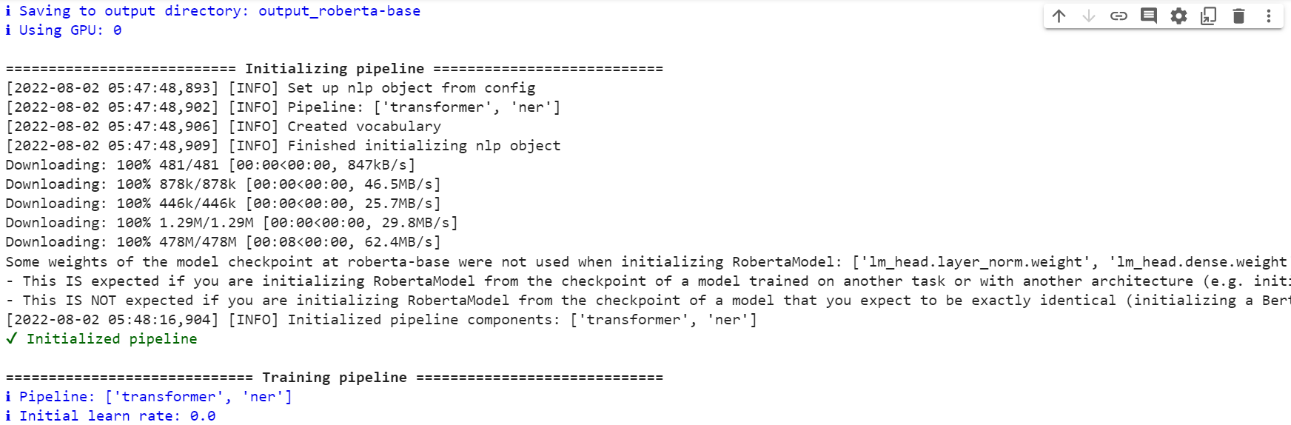

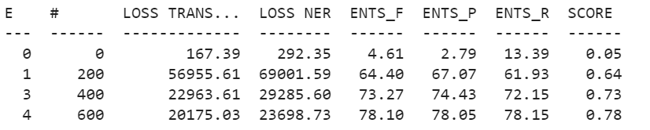

The loss curve plot is as follows:

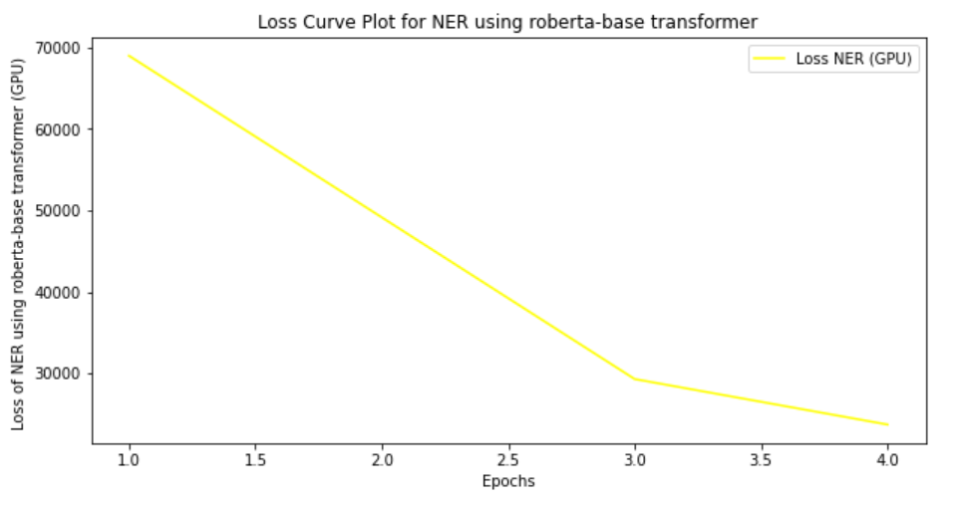

1. Change the name of transformer to ‘**bert-base-uncased**’ inside the config_trf.cfg file.
2. **Training on GPU**:

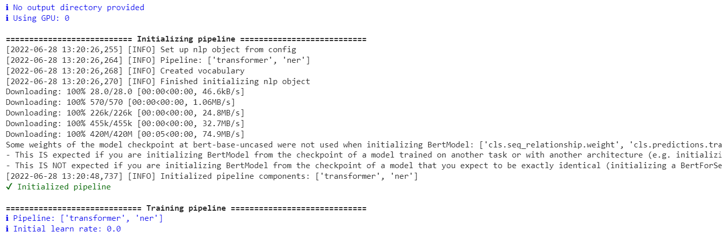

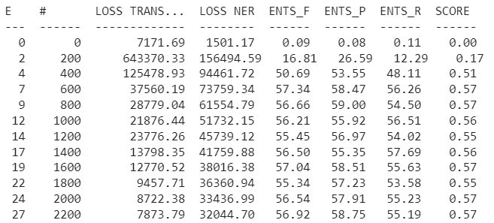

The loss curve plot is as follows:

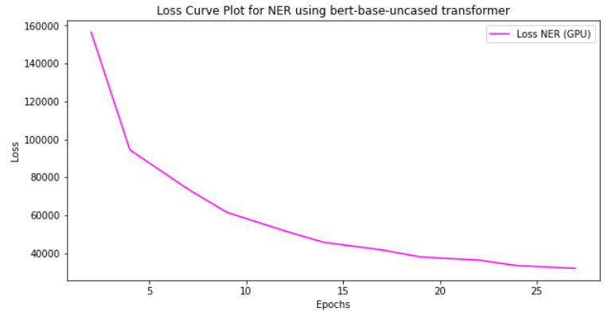

**Approach 2 (Alternative)**:

Use the train command to obtain the performance metrics and save the **output_bert-base-uncased**.

**python -m spacy train ./configs/config_trf.cfg --output ./output_bert-base-uncased --paths.train ./corpus/chia_ner_train.spacy --paths.dev ./corpus/chia_ner_dev.spacy --gpu-id 0**

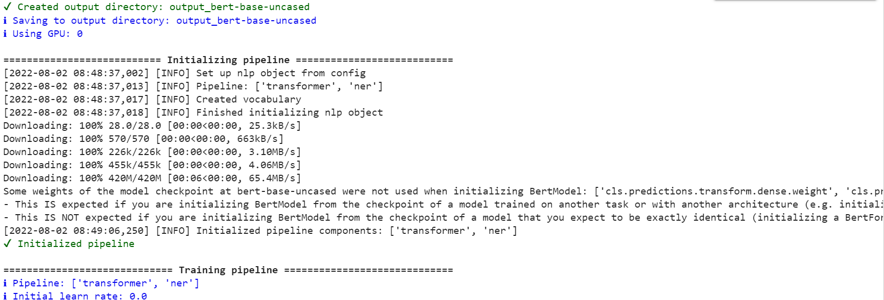

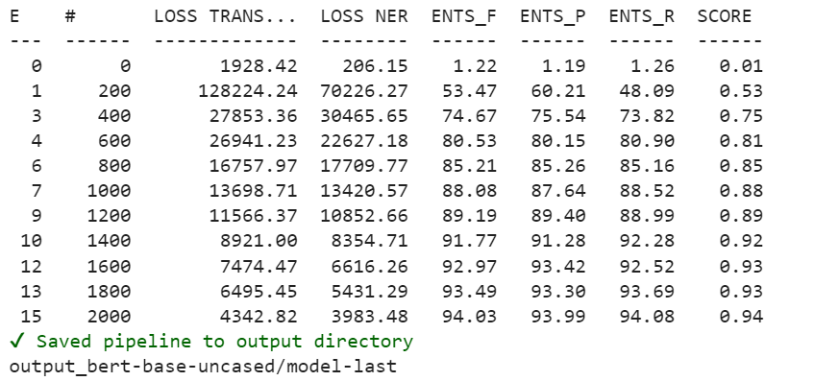

The loss curve plot is as follows:

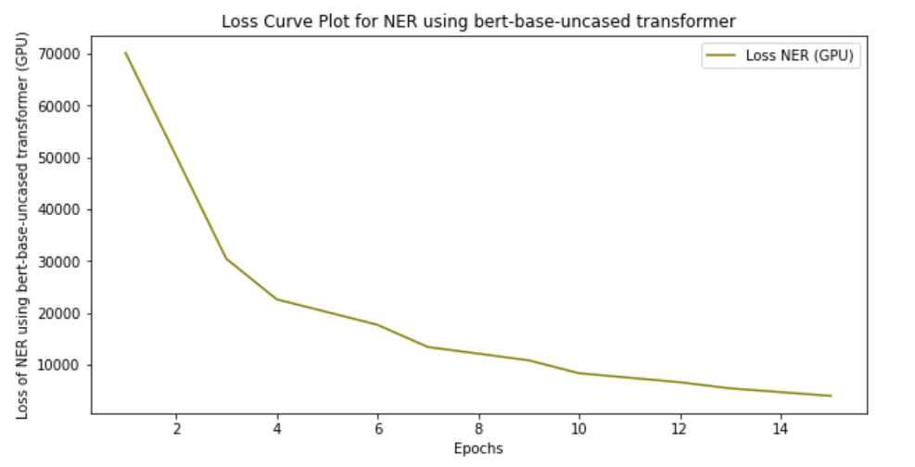

1. Change the name of transformer to ‘**bionlp/bluebert_pubmed_mimic_uncased_L-12_H-768_A-12**’ inside the config_trf.cfg file.
2. **Training on GPU**:

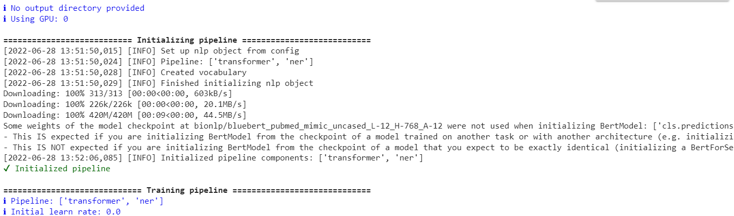

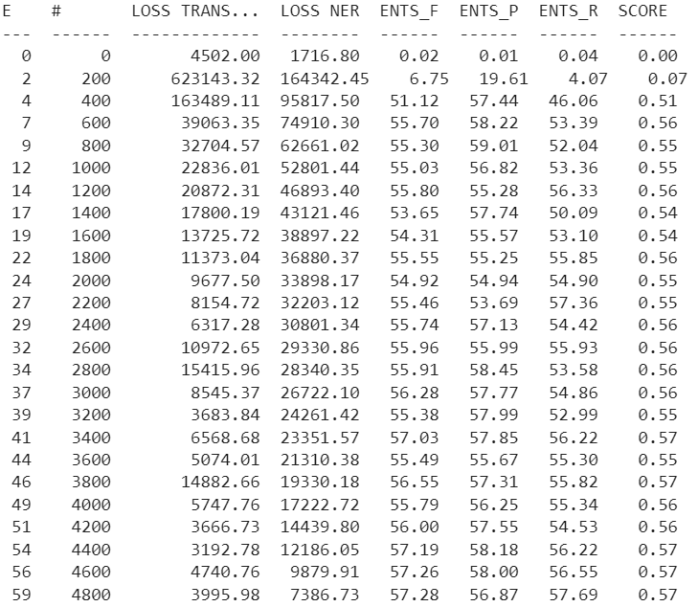

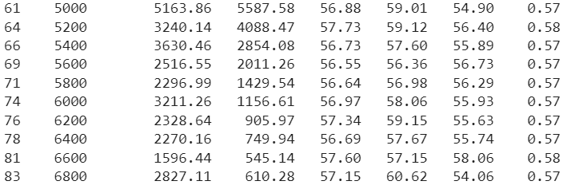

The loss curve plot is as follows:

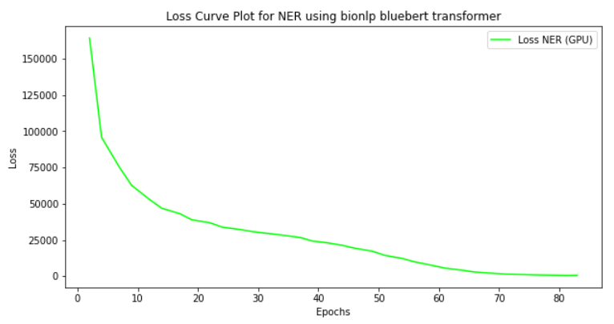

**Approach 2 (Alternative)**:

Use the train command to obtain the performance metrics and save the **output_bionlp_bluebert**.

**python -m spacy train ./configs/config_trf.cfg --output ./output_bionlp_bluebert --paths.train ./corpus/chia_ner_train.spacy --paths.dev ./corpus/chia_ner_dev.spacy --gpu-id 0**

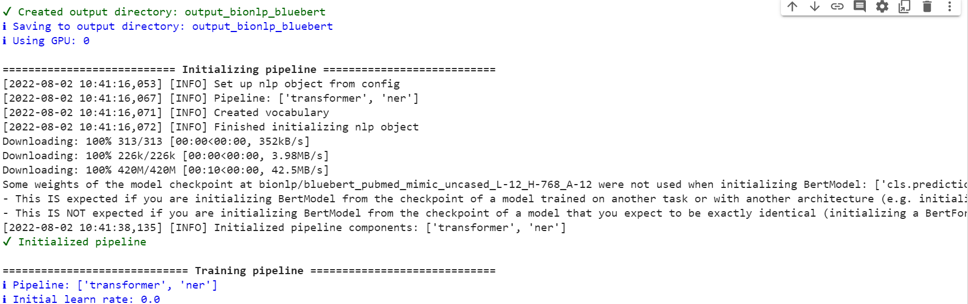

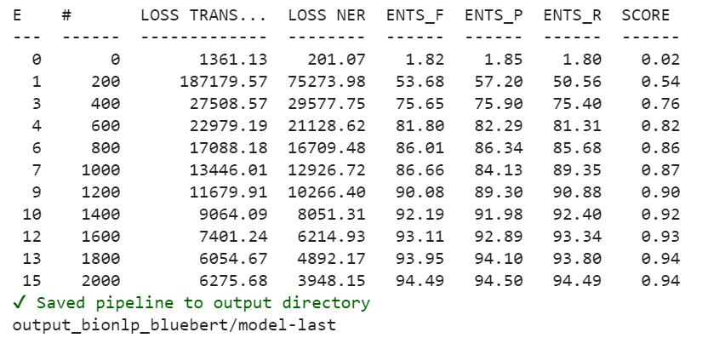

The loss curve plot is as follows:

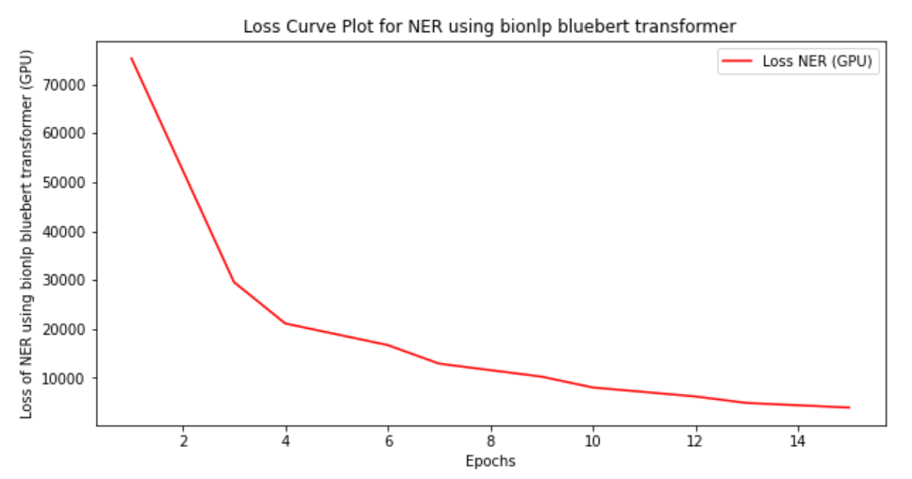

1. **Save the output of the trained NER model**:

* We save the trained NER model inside the output using the following command:

**python -m spacy train ./configs/config_trf.cfg --output ./output --paths.train ./corpus/chia_ner_train.spacy --paths.dev ./corpus/chia_ner_dev.spacy --gpu-id 0**

* It will create 2 folders: model-best and model-last. Both these folders will contain subfolders like ner, transformer, vocab and also config.cfg, meta.json and tokenizer files.
* Download the output folder (model-best) inside the local system and serve it inside the FASTAPI code to get the entities and test the REST queries like GET and POST on POSTMAN.
* Test the results of model for different transformers like roberta-base, bert-base-uncased and **bionlp/bluebert_pubmed_mimic_uncased_L-12_H-768_A-12.**

**Relationship Extraction (REL)**:

1. The code for **generate_spaCy_data_rel.ipynb** and **TestSpaCyOutput_rel.ipynb** were written inside the Jupyter notebook. (Without using standoff2conll repository)
2. In this method a blank English model of spacy was loaded using **nlp = spacy.blank("en")**.
3. Top 10 entities like "Condition", "Scope", "Qualifier", "Value", "Drug", "Procedure", "Measurement", "Temporal", "Observation", "Person" were highlighted from Chia dataset.
4. Missing entities were excluded, and the data was processed for carrying out training using NER.
5. The dataset was then converted to **chia_rel_full.spacy** file.
6. Next, the testing of spacy output was carried out using **docbin=DocBin().**
7. The dataset was split into training, testing and validation (80%, 10%, 10%) respectively using sklearn model selection method and random shuffling method.
8. Dump to disk function was used to save the split dataset into **chia_rel_train.spacy**, **chia_rel_test.spacy** and **chia_rel_dev.spacy.**
9. Inside the repository (**chia_clinical_trials/projects/tutorials/rel_component**), we edit the train, test and dev paths in project.yml file.
10. We use the Chia with scope dataset (both inclusion and exclusion) and place the annotated (.ann) files inside **chia_clinical_trials/projects/tutorials/rel_component/assets** folder.
11. Pipeline used is Pipeline = [‘tok2vec’, ‘relation_extractor’].
12. Then we proceed to the workflow. Using the command **python -m spacy project run all**. It performs data preprocessing, trains the model on cpu (train_cpu) and evaluates the model.
13. We obtain the following REL scores of precision, recall, F1 score (inside the CPU).

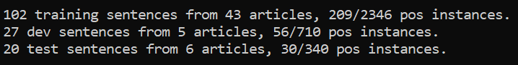

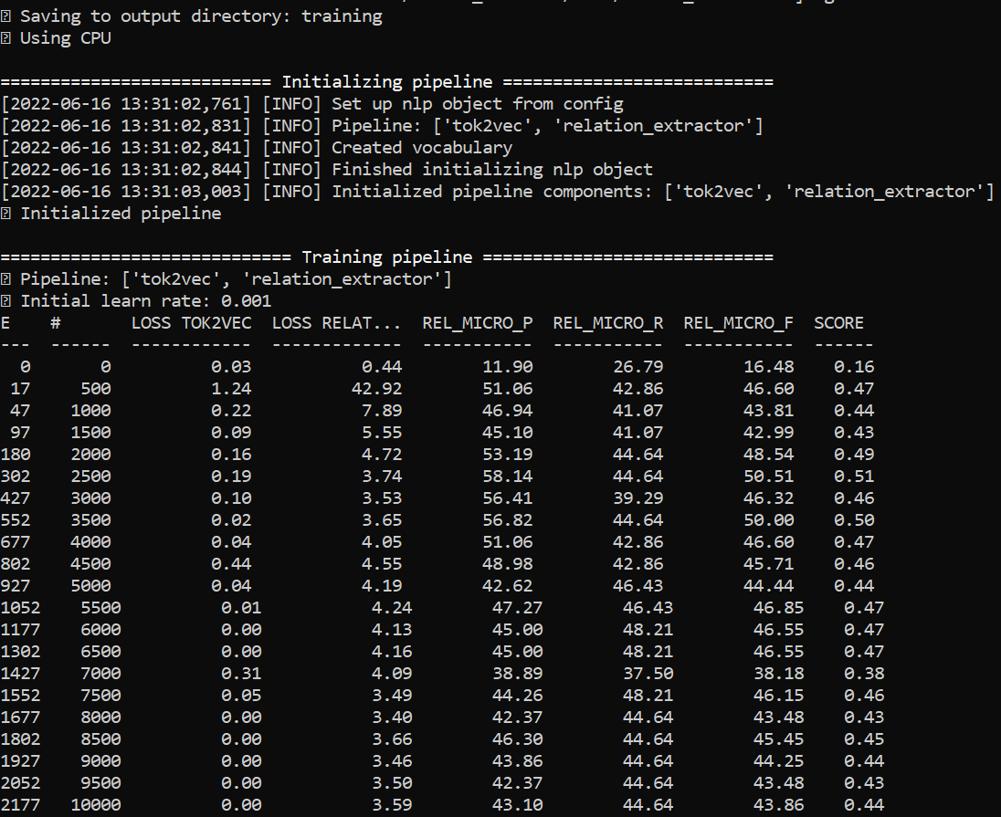

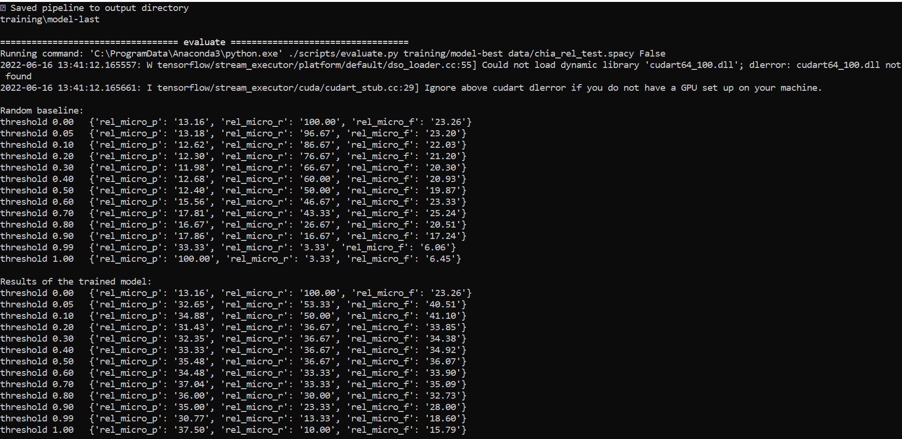

1. The same command was used inside the Google Colaboratory and following results are obtained for REL scores. Inside Google Colaboratory, we set the runtime type= “CPU”.

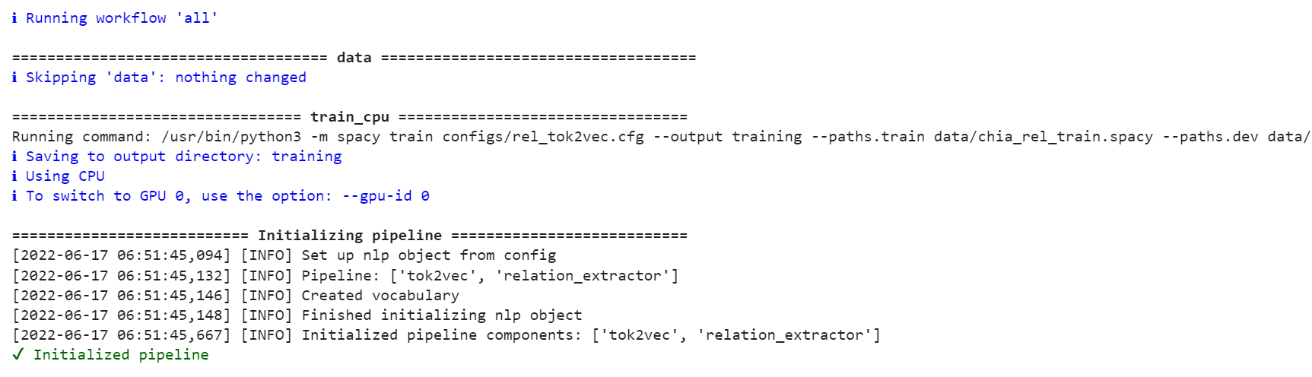

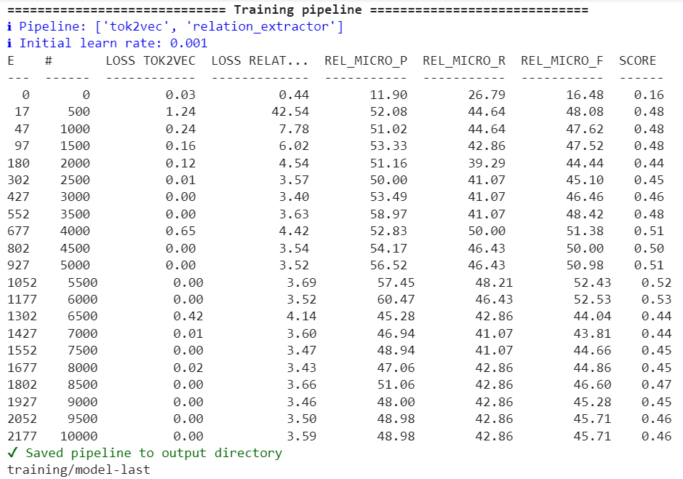

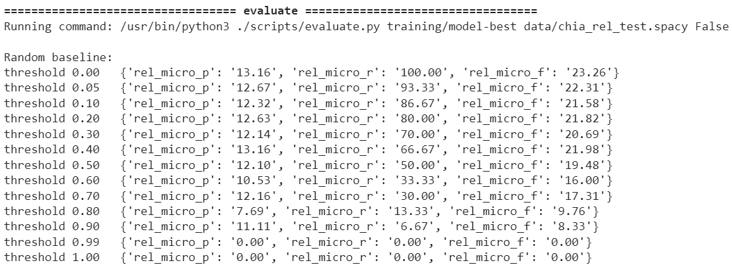

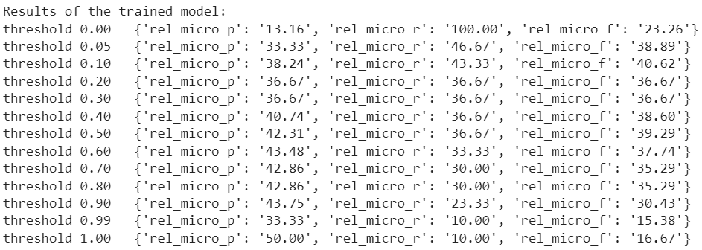

The loss curve plot is as follows:

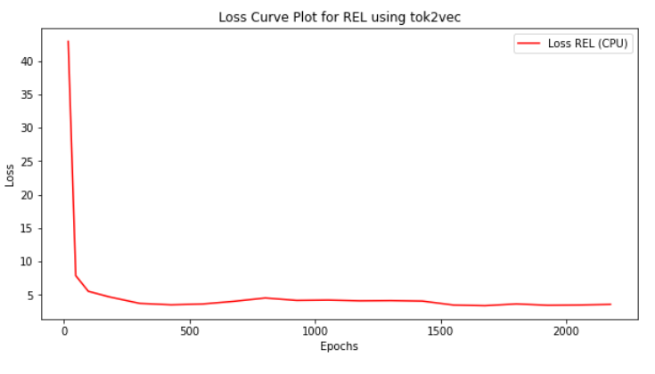

1. **Save the trained REL model**: We save the trained NER model inside the disk using the following code

output_dir = './rel-model'

nlp.to_disk(output_dir)

print("Saved model to", output_dir)

1. Now inside Google Colaboratory, we set the runtime type= “GPU”.
2. Installing spacy transformers: **pip install spacy-transformers**.
3. Pipeline used is Pipeline = [‘transformer’, ‘relation_extractor’].
4. To run the REL inside the GPU using different transformers we use the command **python -m spacy project run all_gpu**. It performs data preprocessing, trains the model on gpu (train_gpu) and evaluates the model.
5. Three different types of transformers are used and we obtain the following REL scores of precision, recall, F1 score (inside the GPU):
6. Change the name of transformer to ‘**bert-base-uncased**’ inside the rel_trf.cfg file present in

**/content/drive/MyDrive/chia_clinical_trials/projects/tutorials/rel_component/configs/** directory.

1. **Training on CPU**:

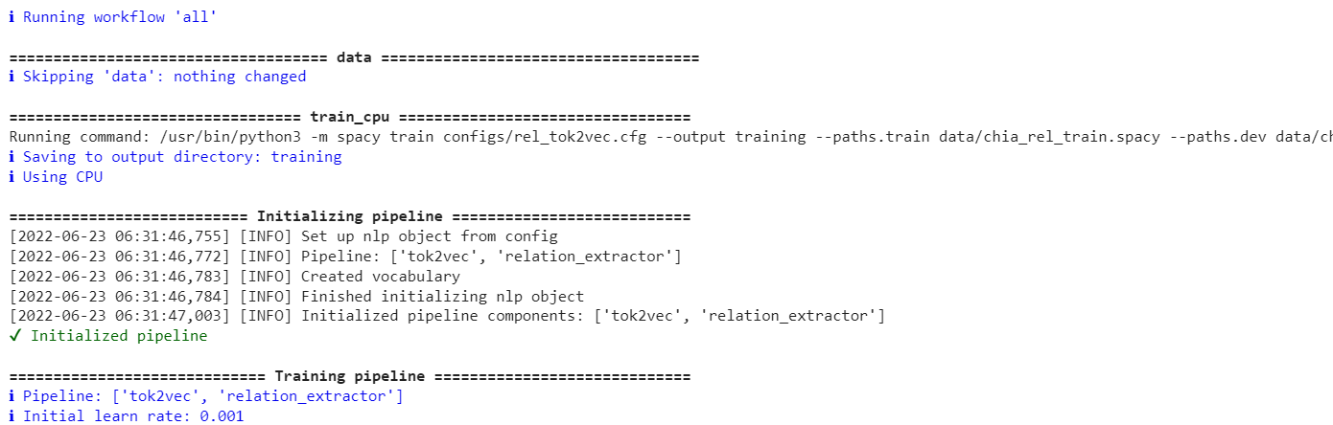

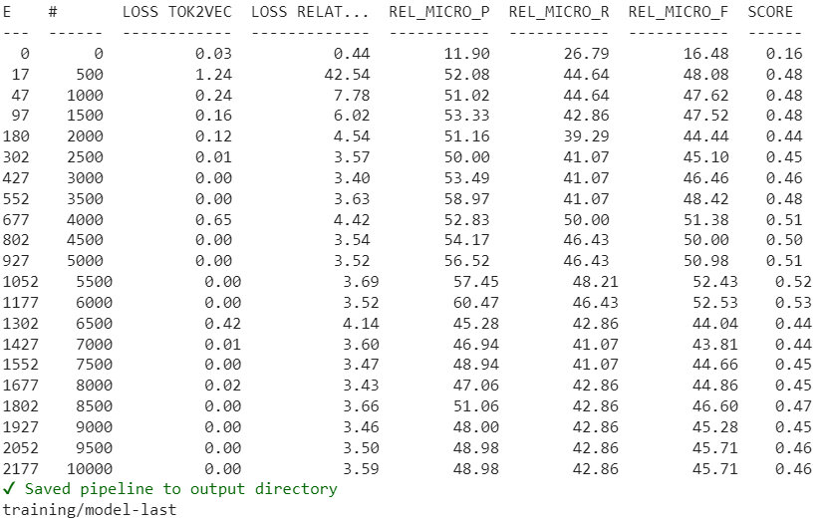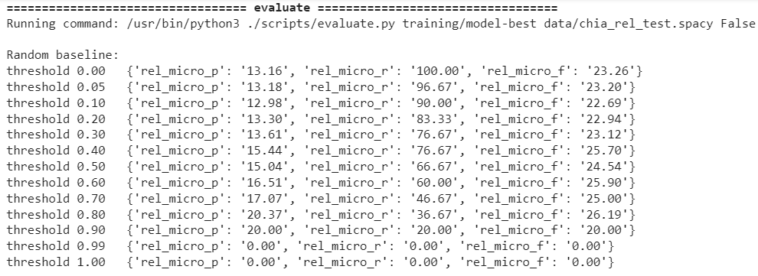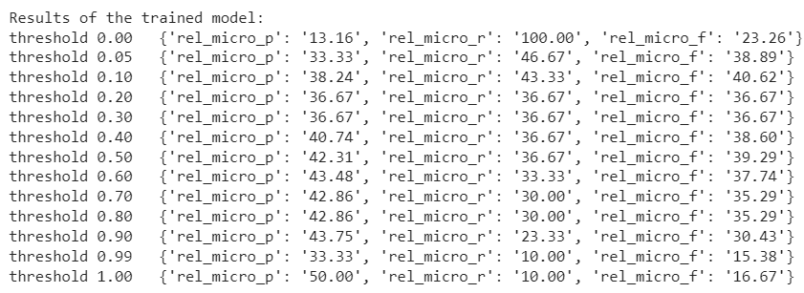

1. **Training on GPU**:

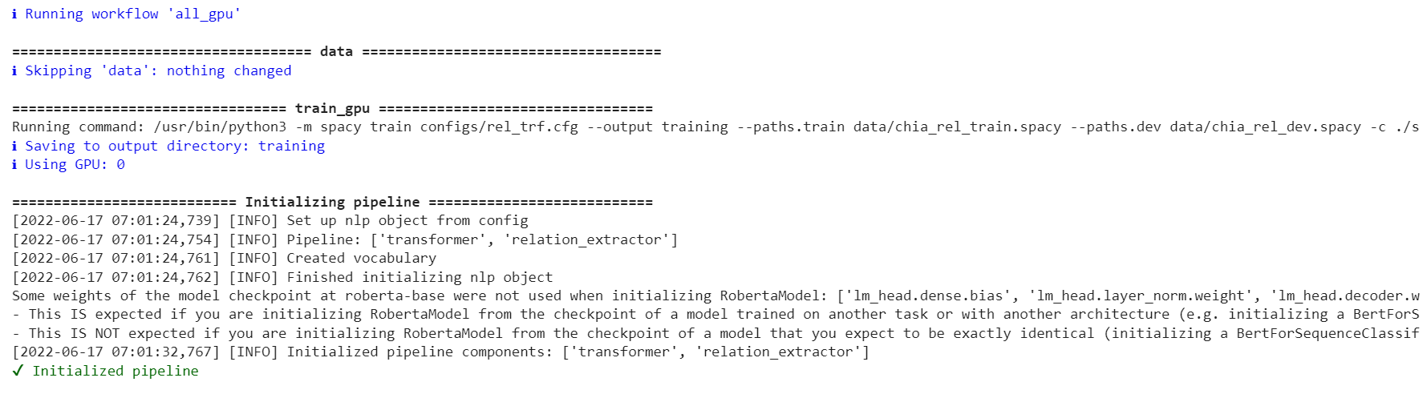

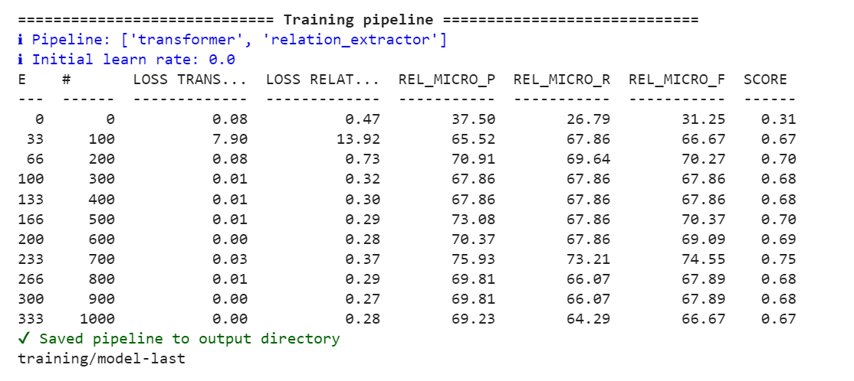

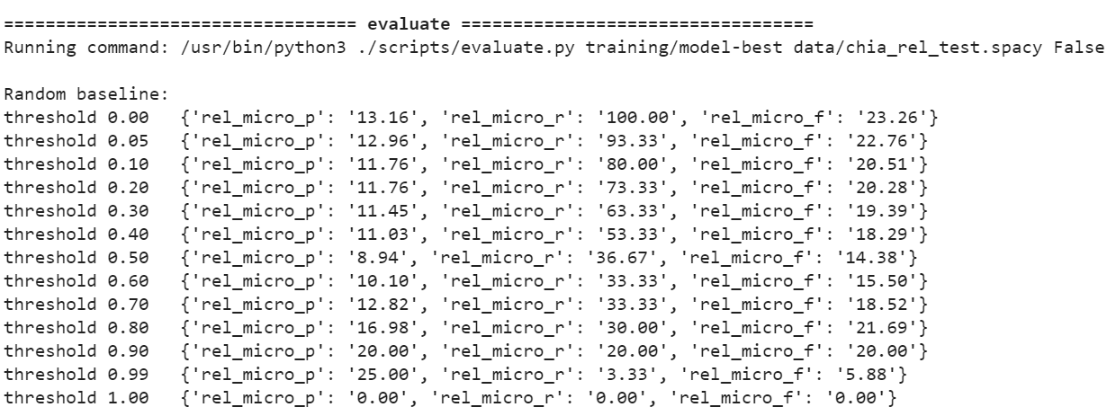

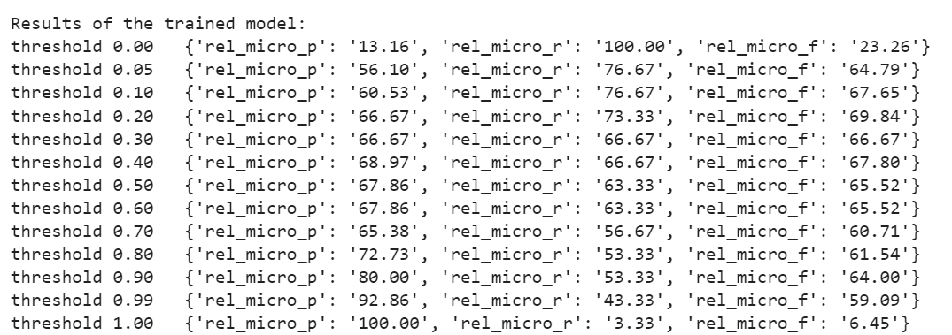

The loss curve plots are as follows:

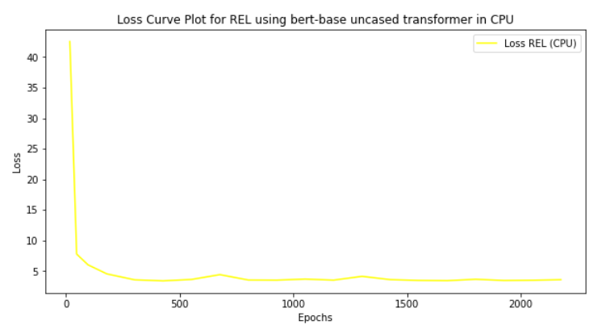 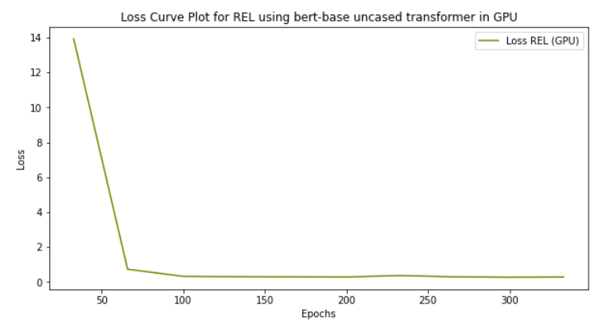

1. Change the name of transformer to ‘**bionlp/bluebert_pubmed_mimic_uncased_L-12_H-768_A-12**’ inside the inside the rel_trf.cfg file present in **/content/drive/MyDrive/chia_clinical_trials/projects/tutorials/rel_component/configs** directory.
2. **Training on CPU**:

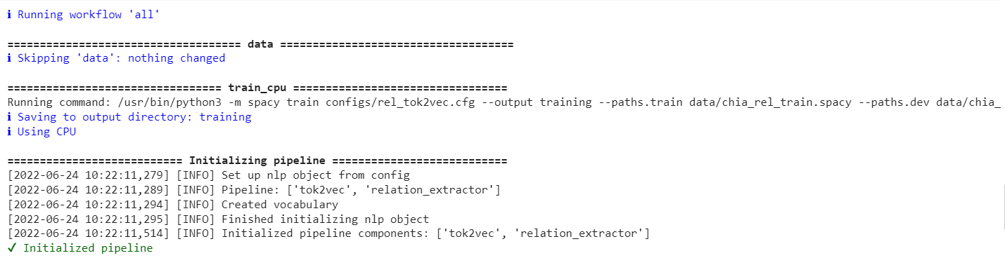

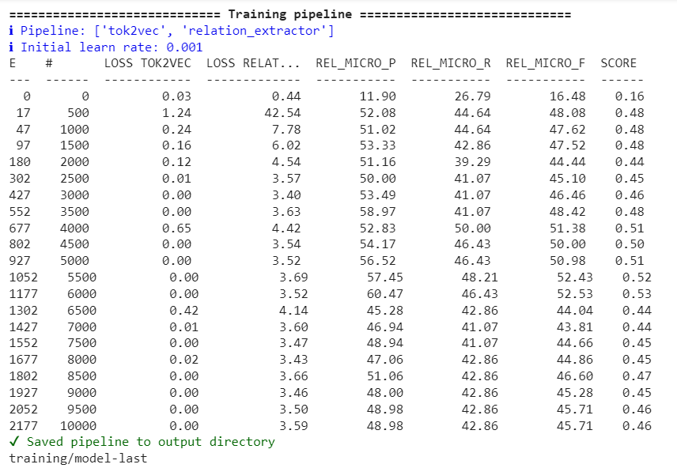

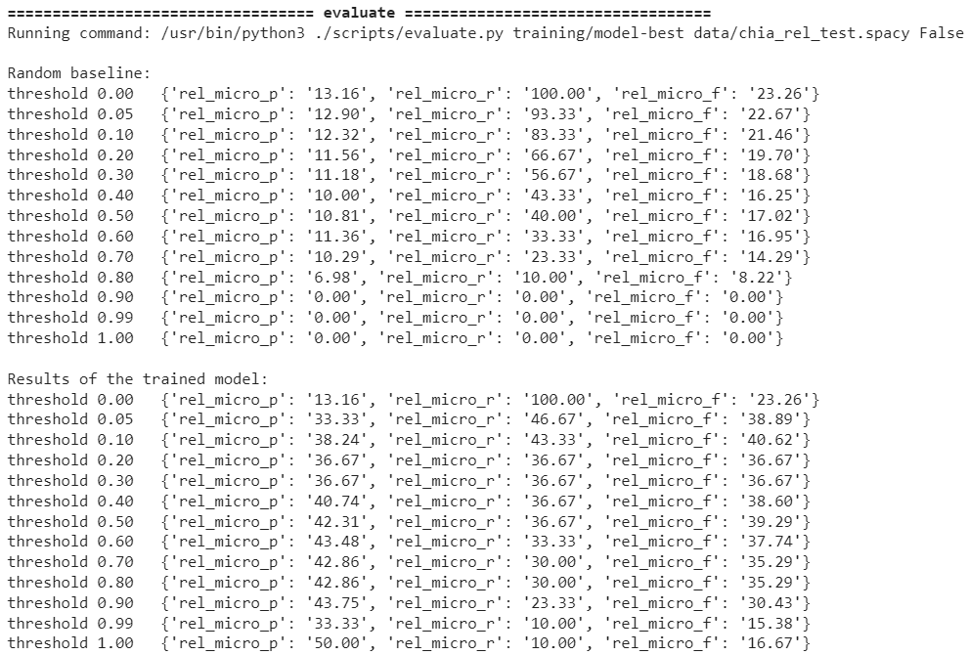

1. **Training on GPU**:

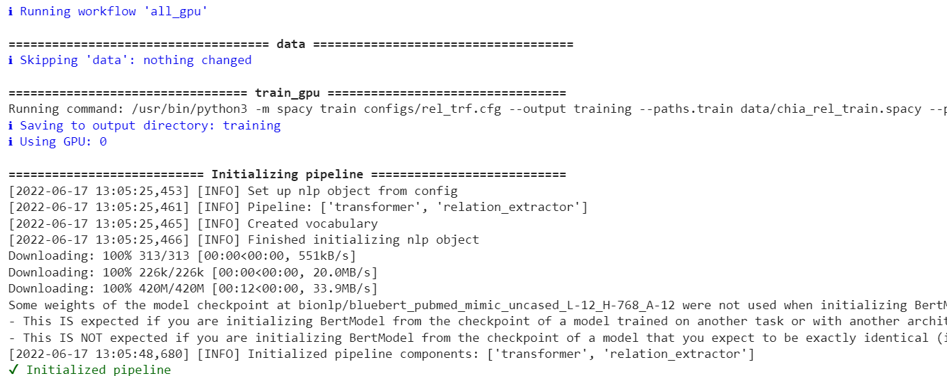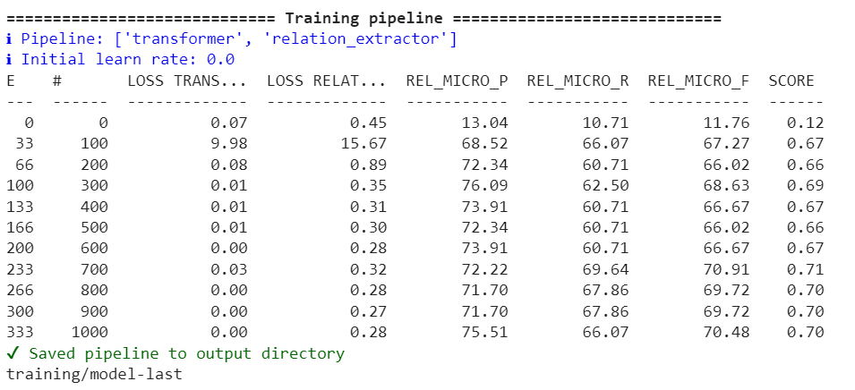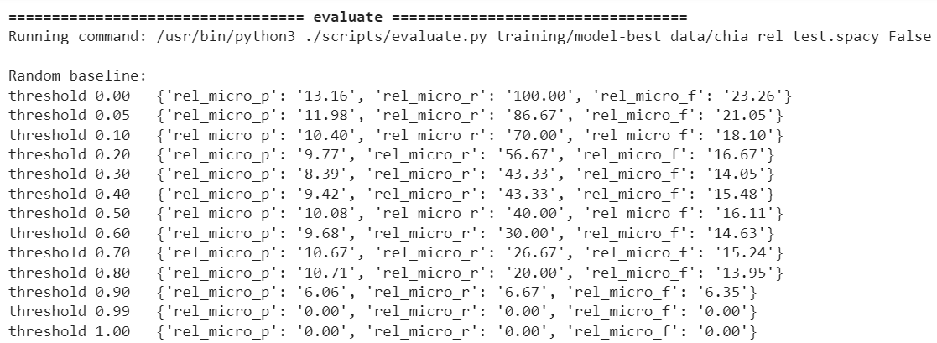

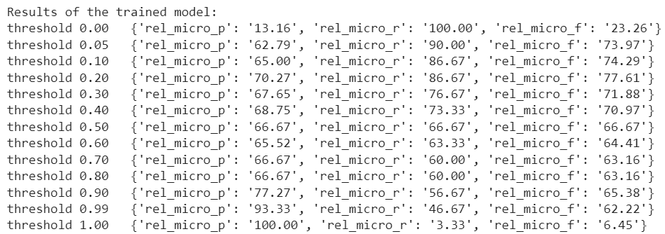

The loss curve plots are as follows:

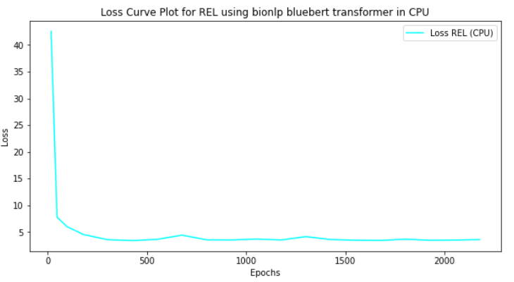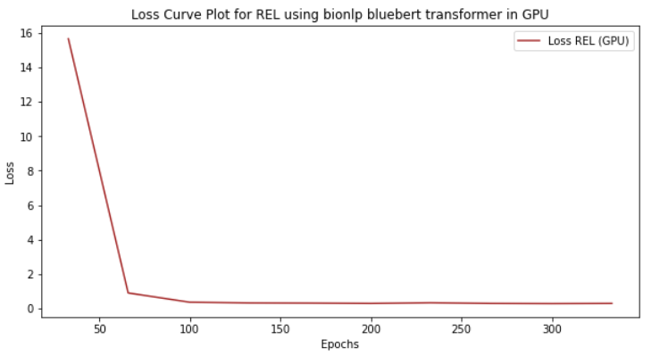

1. Change the name of transformer to ‘**roberta-base**’ inside the rel_trf.cfg file present in

**/content/drive/MyDrive/chia_clinical_trials/projects/tutorials/rel_component/configs/** directory.

1. **Training on CPU**:

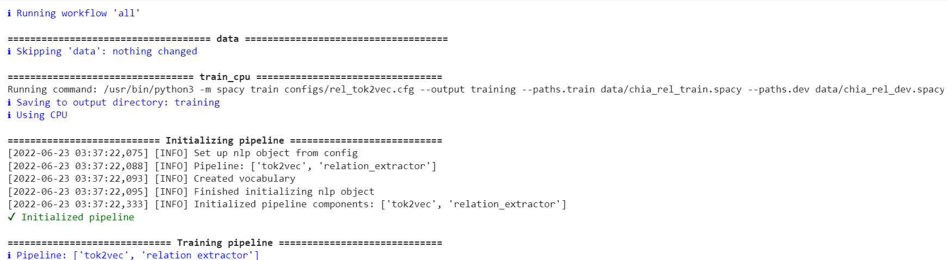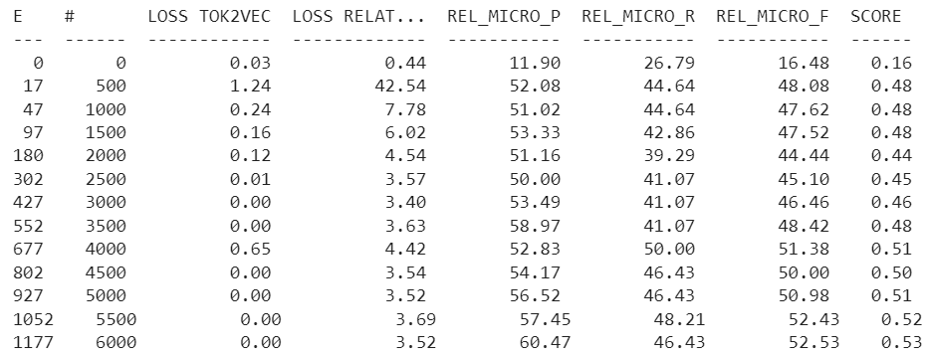

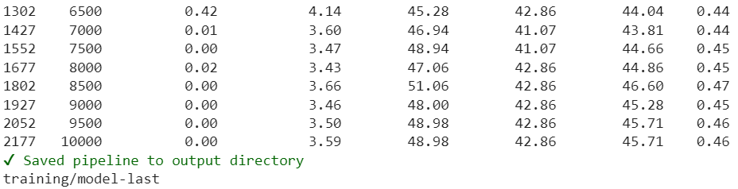

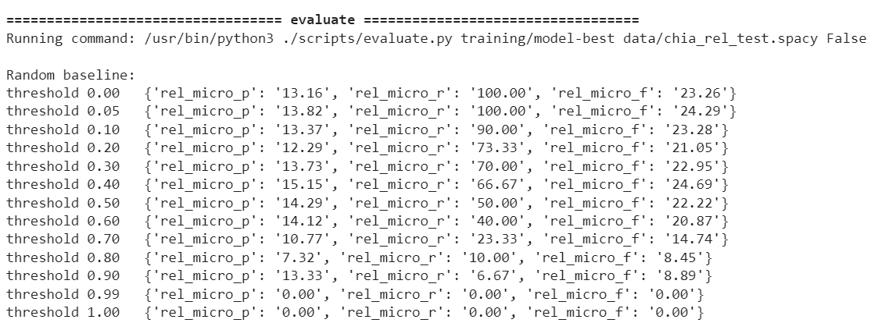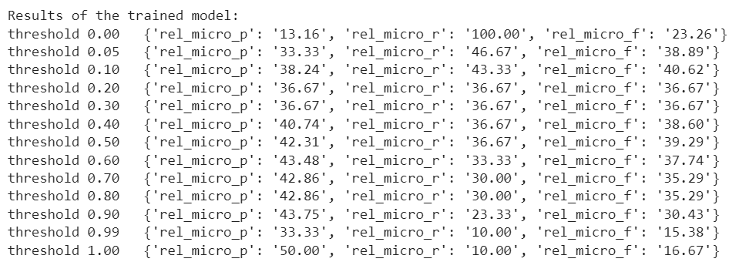

1. **Training on GPU**:

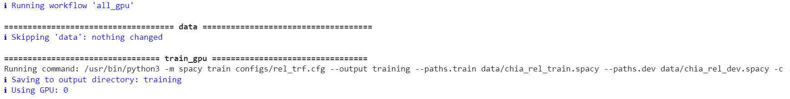

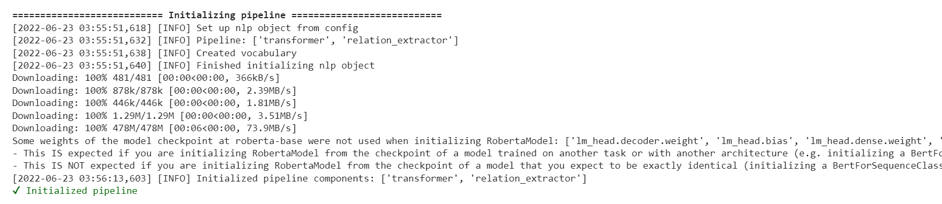

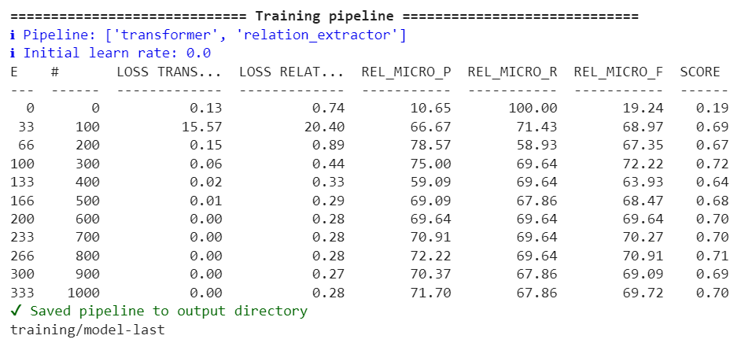

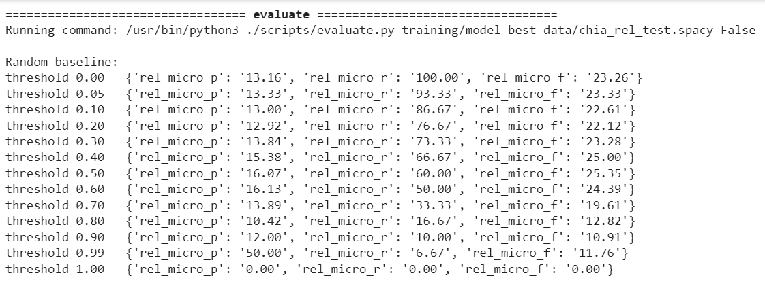

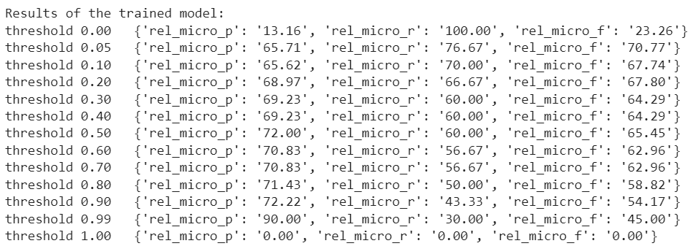

The loss curve plots are as follows:

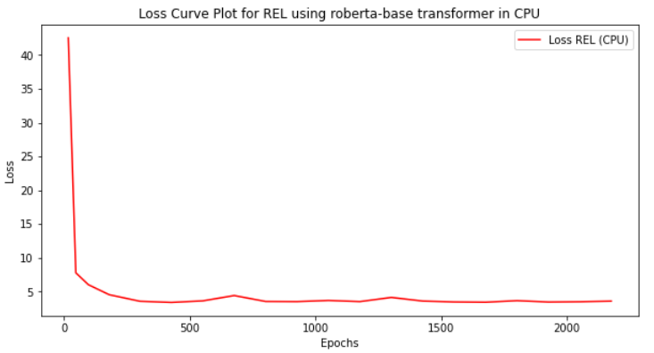 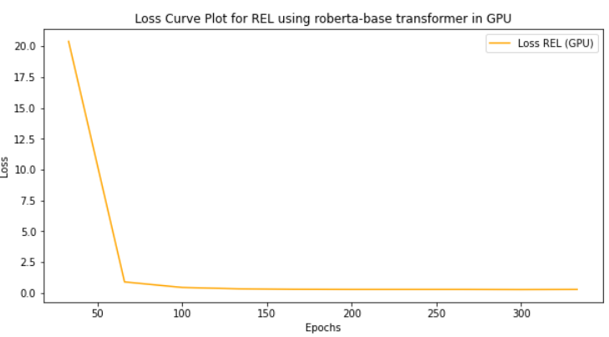

**Alternative Approach to improve REL**

1. Make the necessary changes in rel_model.py like set nO=5, include pytorch wrapper etc.

@spacy.registry.architectures("rel_model.v1")

def create_relation_model(create_instance_tensor: Model[List[Doc], Floats2d],

nO: int=None,

nI: int=None,

hidden_width: int=None

) -> Model[List[Doc], List[Floats2d]]:

print("im here" ,nI,nO)

hidden_width = 1024

h_w4 = 256

h_w5 = 128

nO = 5

nI = 1536

h_w2 = 768

h_w3 = 512

torch_model = nn.Sequential(

nn.Linear(nI, hidden_width),

nn.ReLU(),

nn.Linear(hidden_width, h_w2),

nn.ReLU(),

nn.Linear(h_w2, h_w3),

nn.ReLU(),

nn.Linear(h_w3, h_w4),

nn.ReLU(),

nn.Linear(h_w4, h_w5),

nn.ReLU(),

nn.Linear(h_w5, nO),

nn.Softmax(dim=1)

)

wrapped_pt_model = PyTorchWrapper(torch_model)

model = chain(create_instance_tensor, with_array(wrapped_pt_model))

model.attrs["get_instances"] = create_instance_tensor.attrs["get_instances"]

return model

1. Inside custom_functions.py, remove the classification layer from import libraries

from scripts.rel_model import create_relation_model,create_instances, create_tensors

1. Inside rel_trf.cfg, include

[components.relation_extractor.model]

@architectures = "rel_model.v1"

nI = null

nO = null

and remove [components.relation_extractor.model.classification_layer]

@architectures = "rel_classification_layer.v1"

nI = null

nO = null

1. Repeat same step 3 in rel_tok2vec.cfg.

**Training on GPU**:

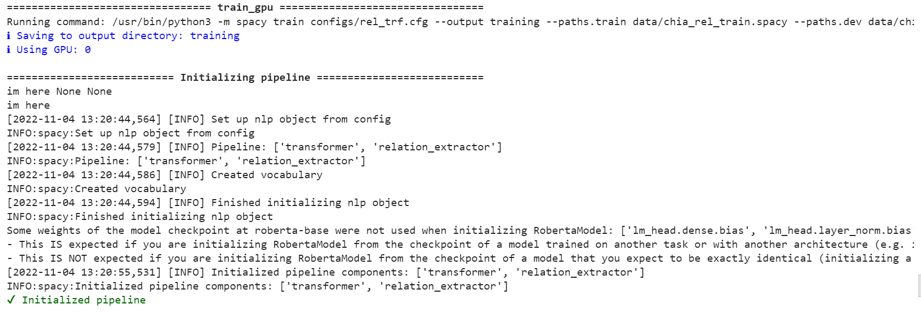

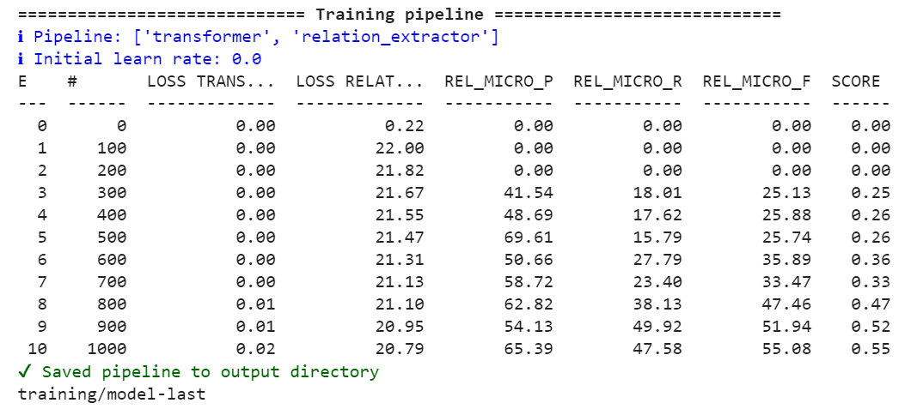

The loss curve plots are as follows:

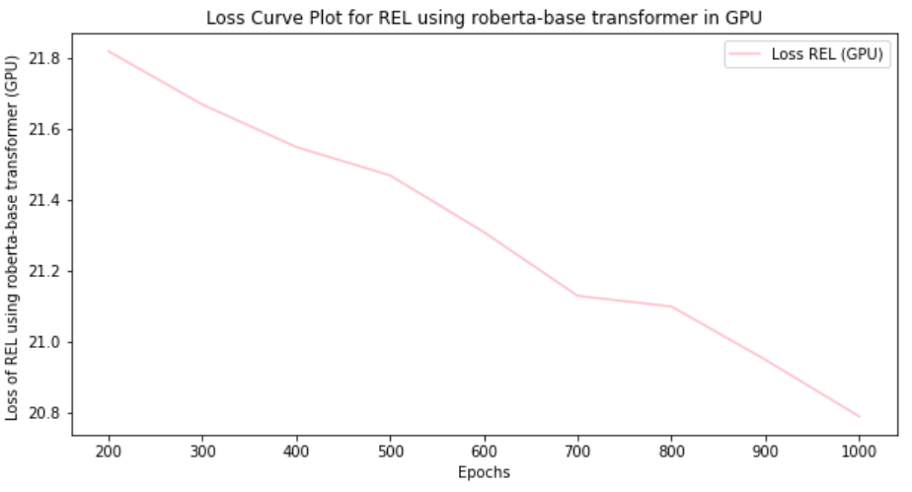

**Combined Pipeline (NER + REL) Using Tok2vec and Transformer**:

1. Create a configuration file ner_rel_trf.cfg in

**/content/drive/MyDrive/chia_clinical_trials/projects/tutorials/rel_component/configs** directory.

1. Use the Pipeline: pipeline = ["transformer", "ner","relation_extractor"].
2. Traverse to **/content/drive/MyDrive/chia_clinical_trials/projects/tutorials/rel_component/** directory.
3. Inside **project.lock** file, edit script for **train_gpu** as

**python -m spacy train configs/ner_rel_trf.cfg --output training --paths.train data/chia_rel_train.spacy --paths.dev data/chia_rel_dev.spacy -c ./scripts/custom_functions.py --gpu-id 0**

1. Inside **project.yml** file, edit the variable, trf_config: "**configs/ner_rel_trf.cfg**".
2. Use the train command to calculate REL F1, Precision and Recall scores.

* **python -m spacy project run all_gpu**

1. **GPU Results**
2. Change transformer = ‘**roberta-base’** inside the ner_rel_trf.cfg file.

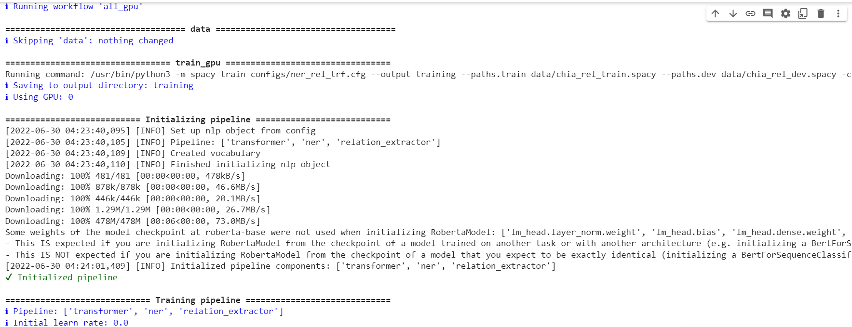

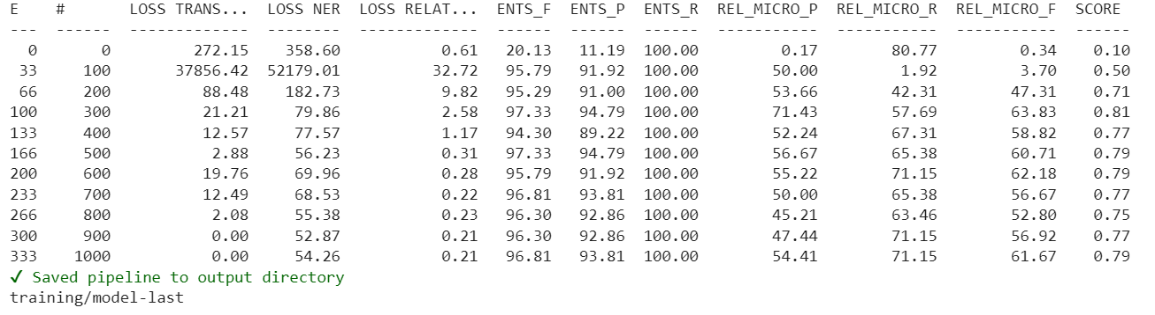 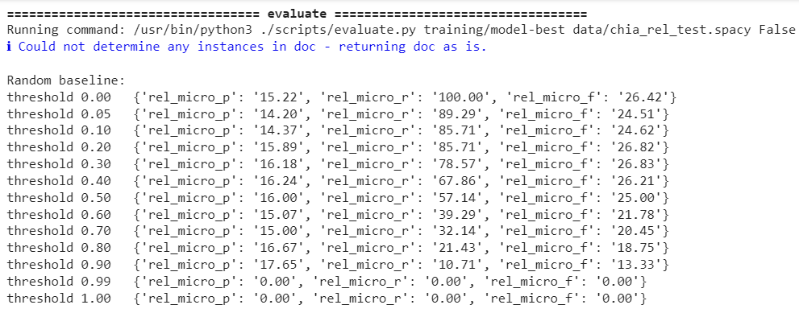 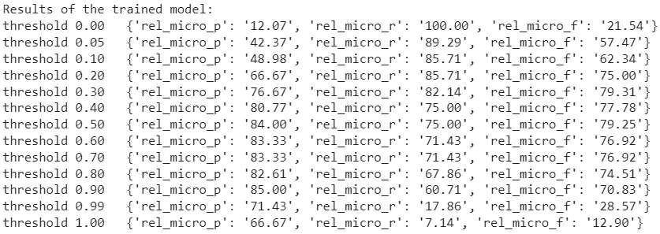

The loss curve plot is as follows:

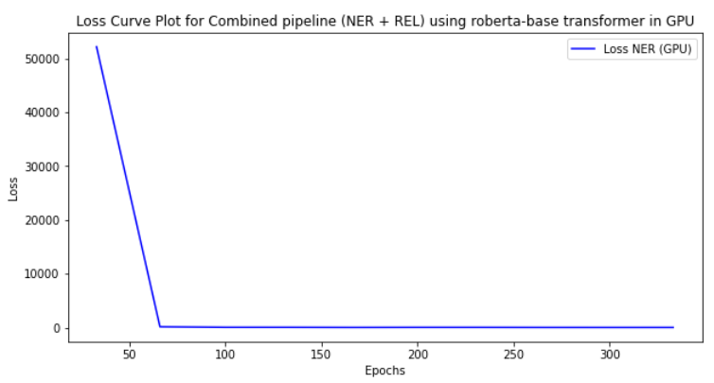 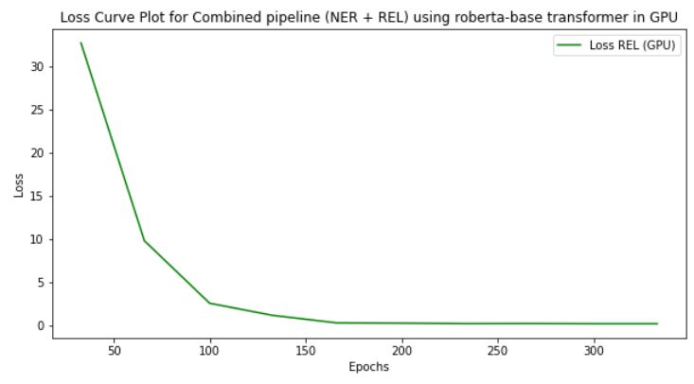

1. Change transformer = ‘**bert-base-uncased’** inside the ner_rel_trf.cfg file.

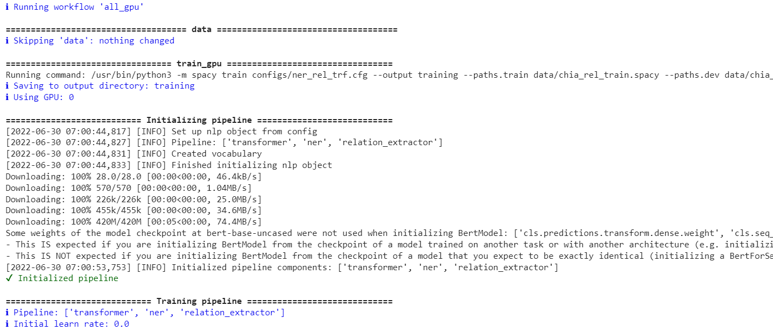

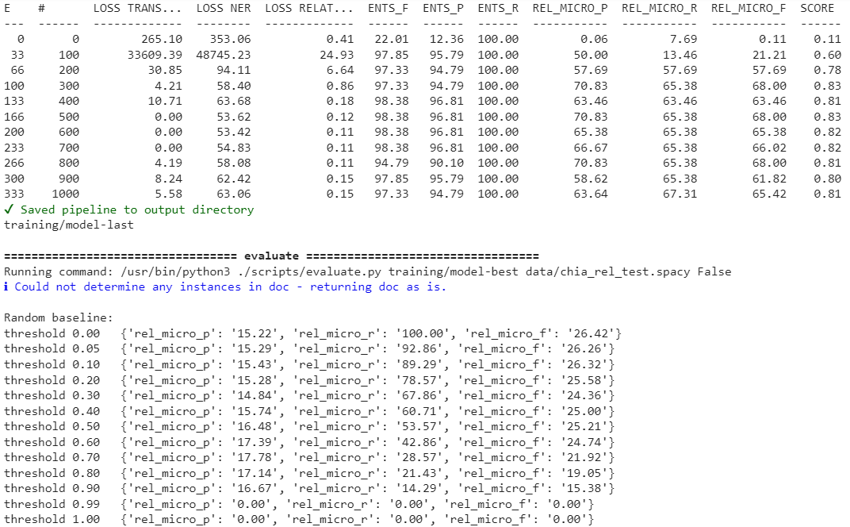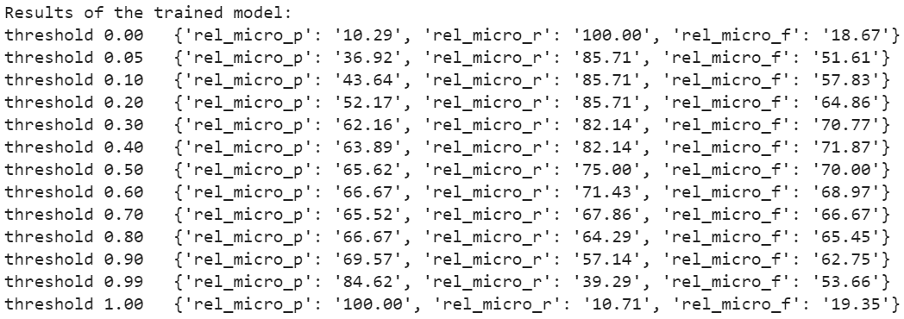

The loss curve plot is as follows:

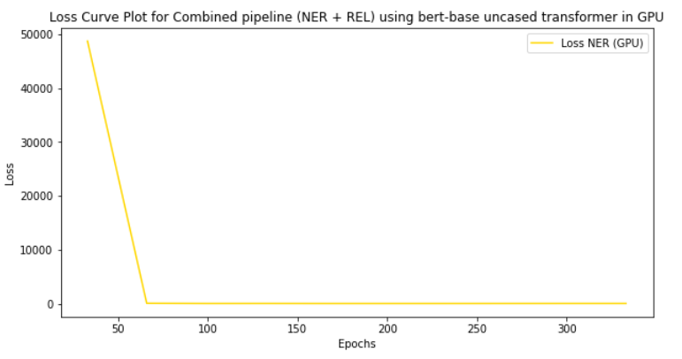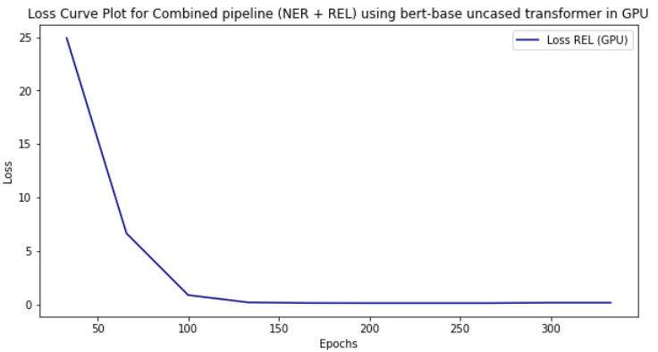

1. Change transformer = ‘**bionlp/bluebert_pubmed_mimic_uncased_L-12_H-768_A-12’** in ner_rel_trf.cfg file.

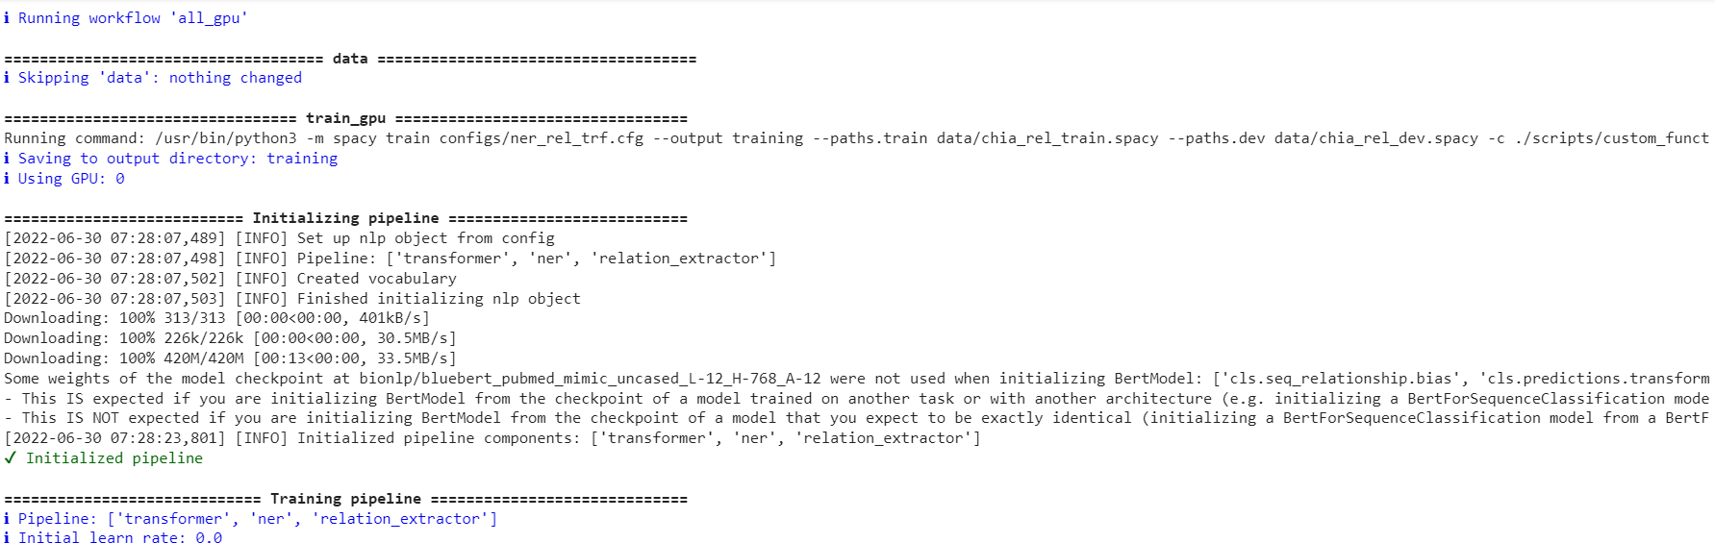

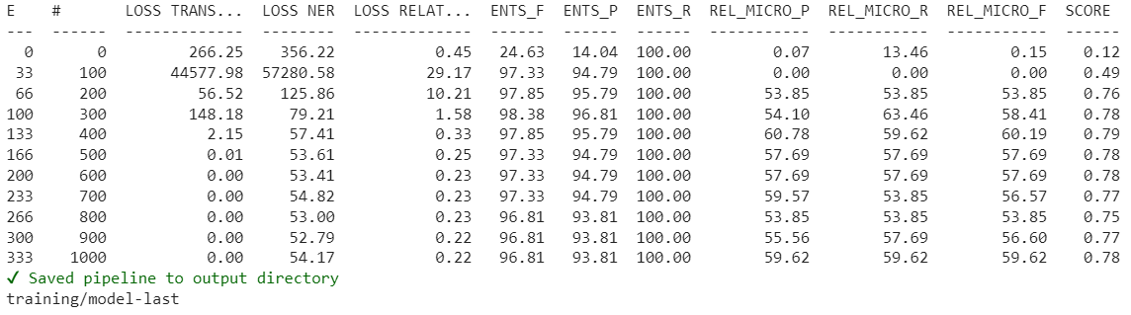

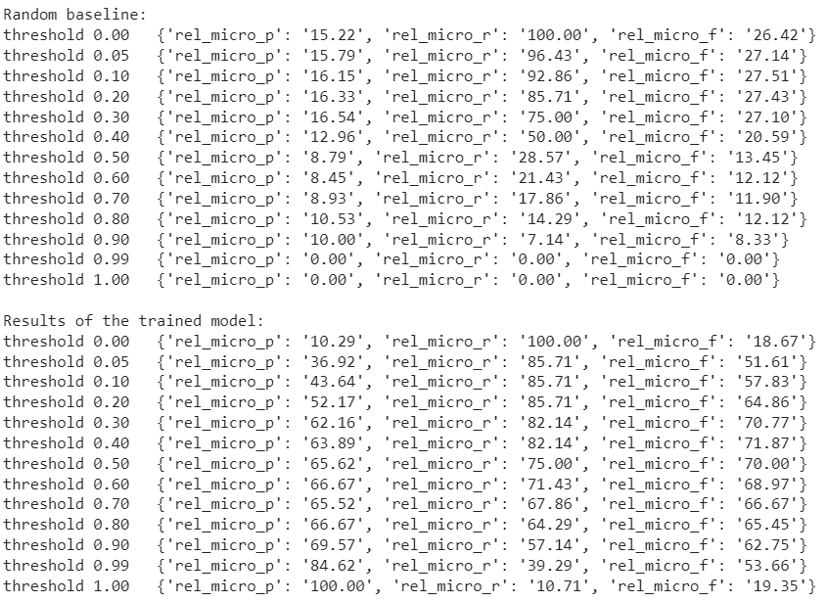

The loss curve plot is as follows:

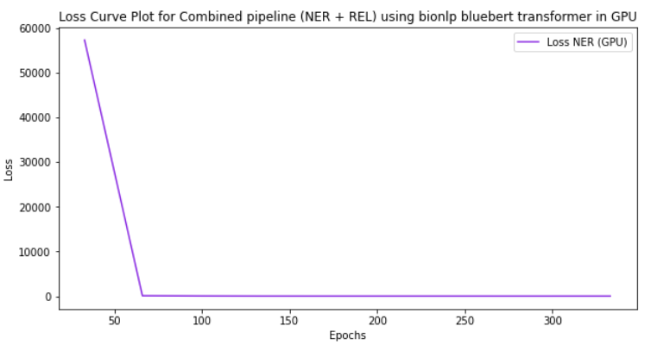 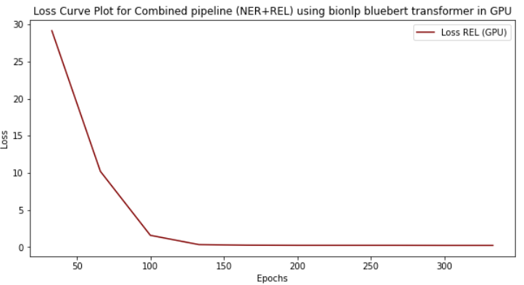

**Comparison of different Models**

|  |  |  |  |  |
| --- | --- | --- | --- | --- |
| **MODELS** | **Performance Metrics** | | | |
| **CPU** | **GPU** | | |
| **NER** | **Tok2VecListener** | **roberta-base** | **bert-base** | **bluebert** |
| **50%** | **60%** | **58%** | **58%** |
| **REL** | **60%** | **78%** | **76%** | **76%** |
| **NER+REL** | **-** | **97% (NER)**  **71% (REL)** | **98% (NER)**  **70% (REL)** | **98% (NER)**  **60% (REL)** |

* For NER model, performance results for training using tok2vec pipeline were 50% using CPU and 60% using GPU.
* Using transformers, Roberta-base architecture performed better compared to bert-base and bluebert architectures.
* For REL model, performance results for training using tok2vec pipeline 60% using CPU and 78% using GPU.
* Using transformers, Roberta-base architecture performed better compared to bert-base and bluebert architectures.

**Packaging a SpaCy English NER Model**

Steps:

1. Create 2 folders **models** and **packaged_models** in **chia_clinical_trials\projects\tutorials\ner_pytorch_medical** directory.
2. Inside command prompt, run the command: **python -m spacy package models/en_core_web-sm packaged_models**
3. This creates the **en_core_web_sm-3.1.0** inside the **packaged_models** directory.
4. Traverse to the directory **packaged_models/ en_core_web_sm-3.1.0** and run the command: **python setup.py sdist**
5. It creates **dist** folder and inside it created **en_core_web_sm-3.1.0.tar.gz** file.
6. Move to **dist** folder and run the command: **python -m** **pip install en_core_web_sm-3.1.0.tar.gz**

Inside Jupyter notebook,

1. Add the custom components and factories to SpaCy model. Create the custom component.
2. Load the base model ‘**en_core_web_sm**’ and analyze the pipes.
3. Add the component to the pipeline.
4. Test the pipeline.
5. Package the model using command:

**python -m spacy package test_pipe compiled --code my_component.py**

**Inferencing the Model**

* We use FastAPI to serve model and get entities. Then, we test REST queries like GET and POST on POSTMAN platform.

Steps for serving the Spacy Model on FastAPI and testing the queries on POSTMAN:

1. Import the required libraries like FastAPI, Request, pydantic, spacy and BaseModel.
2. Declare class Content with BaseModel as parameter. It contains 2 inputs: post_url and content in string format.
3. Declare class Payload with BaseModel as parameter. It contains the variable data which is list of Content class.
4. Declare class SingleEntity with 2 variables: text and entity_type in string format. It is used to display single entity output.
5. Declare class Entities with 2 variables: post_url in string format and entities which is a list of SingleEntity class.
6. Initialize the application app=FastAPI() and load spacy ‘en_core_web_sm’ model and disable other components like ["tok2vec", "tagger", "parser", "attribute_ruler", "lemmatizer"].
7. Input the text and assign it to doc.
8. Create 2 separate function for GET and POST requests.
9. **GET function**: The decorator @app.get(‘/’) is used for the GET function root(). This function returns message ‘S**paCy NER Model using FastAPI’.**
10. **POST function**: The decorator @app.post(**'/ner'**) is used for the POST function get_ner(). Use Payload class in this function and create a tokenized contents in the form of list. This function is used to take multiple inputs of the text and return the number of named entities.
11. Run the code main.py inside Pycharm using command: python -m uvicorn main:app –reload.
12. We can access the output in <http://127.0.0.1:8000> or <http://localhost:8000> which runs the root function.

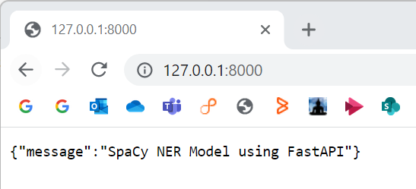

1. We can also check for the FastAPI documentation in <http://127.0.0.1:8000/docs> or <http://localhost:8000/docs> which runs the get_ner function. It generates the output multiple text strings in response.json format.

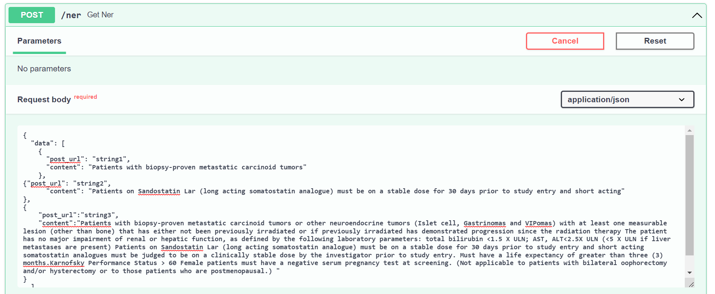

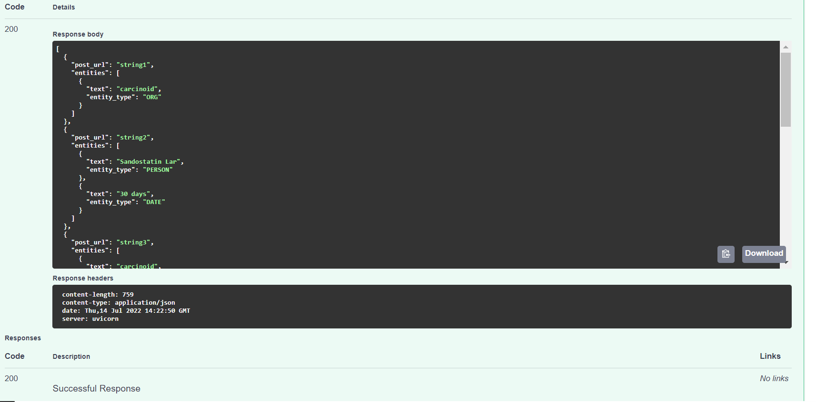

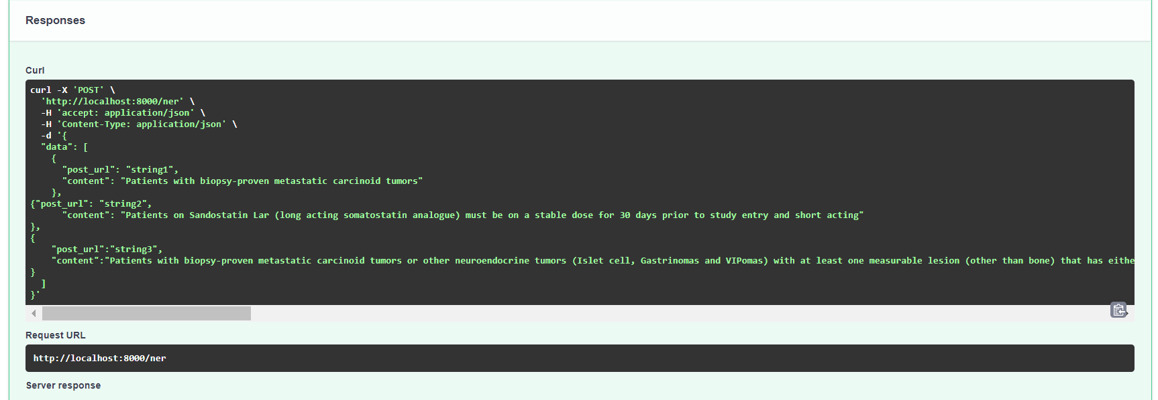

1. The same requests can be checked on the POSTMAN tool. Inside the POSTMAN application, create Collections folder “NER_Model_Chia_Dataset” and inside the folder generate a new workspace. Select the function, paste the URL, and click on send button. It gives 200 OK message means the request is processed successfully.

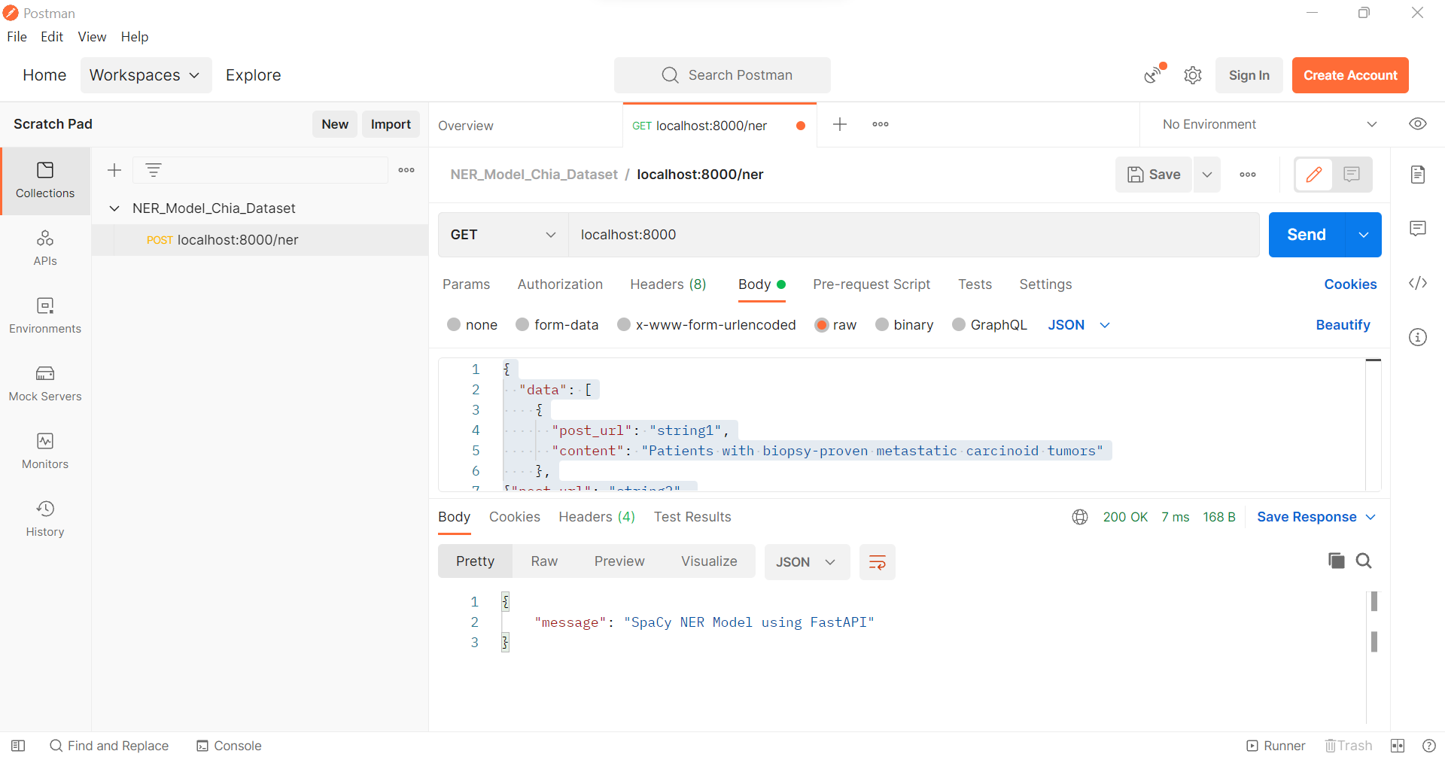

For the POST request, enter the input of multiple texts inside Body and click on raw format in radio button and select JSON format from the list.

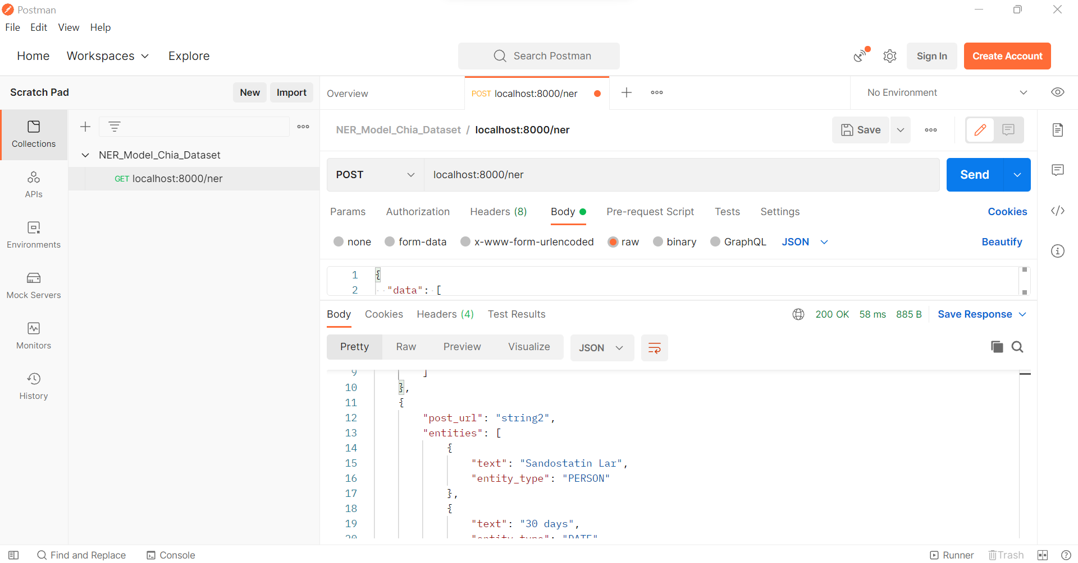

Steps for serving the Trained Chia NER Model on FastAPI and testing the queries on POSTMAN:

1. Repeat steps 1 to 5.
2. Initialize the application app=FastAPI () and load the trained Chia NER model and disable other components like ["tok2vec", "tagger", "parser", "attribute_ruler", "lemmatizer"].
3. Repeat steps 7 to 13.
4. For FastAPI documentation results in <http://127.0.0.1:8000/docs> or <http://localhost:8000/docs>.

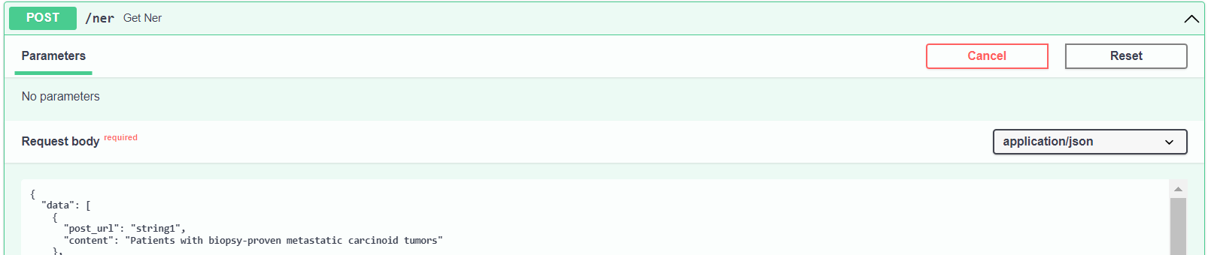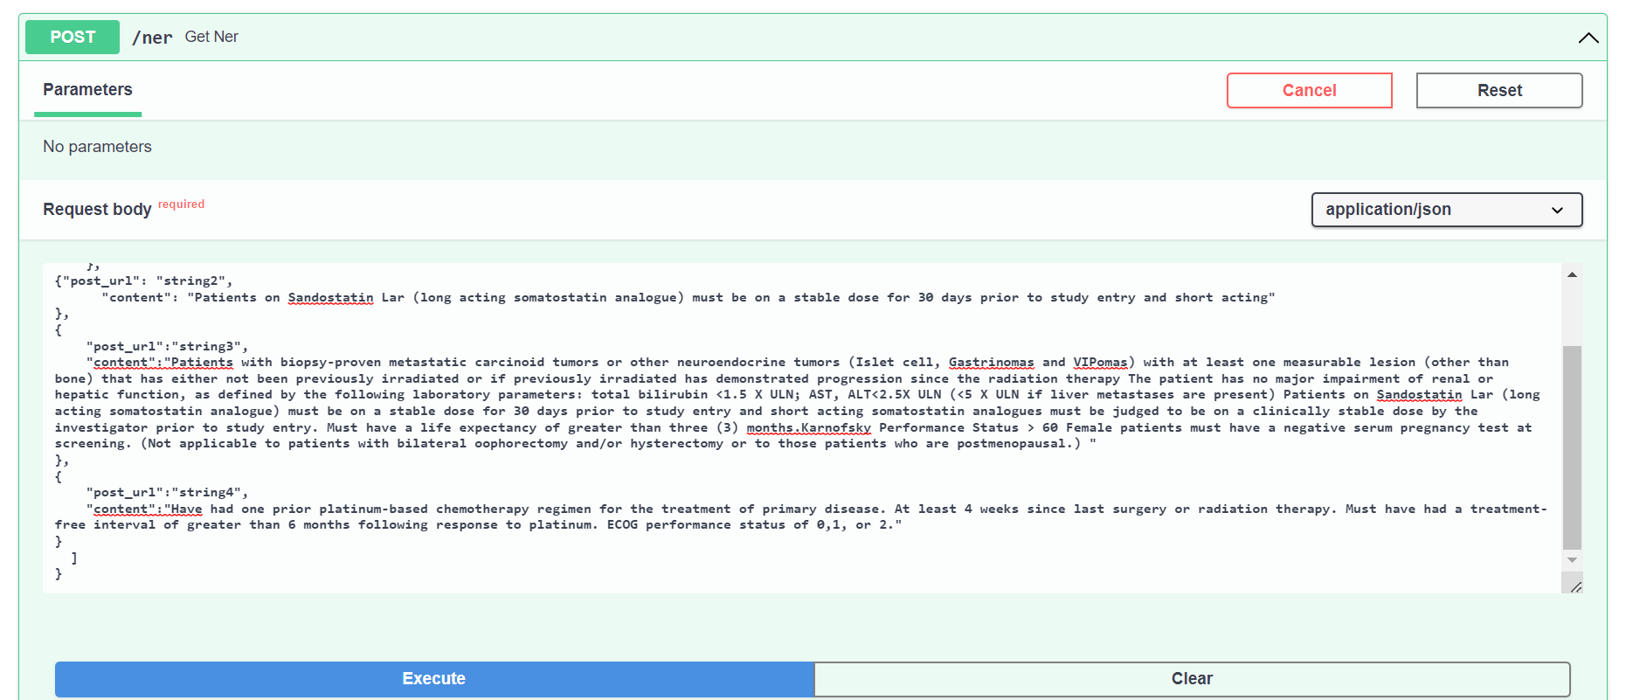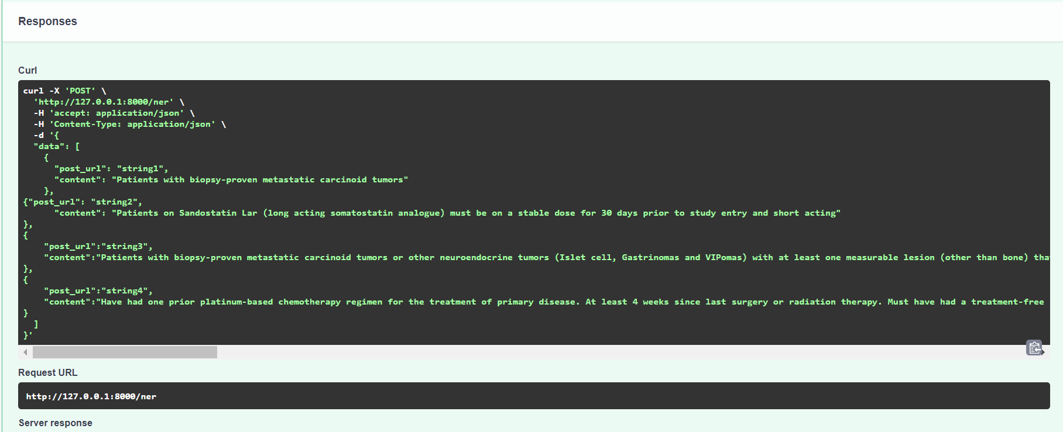

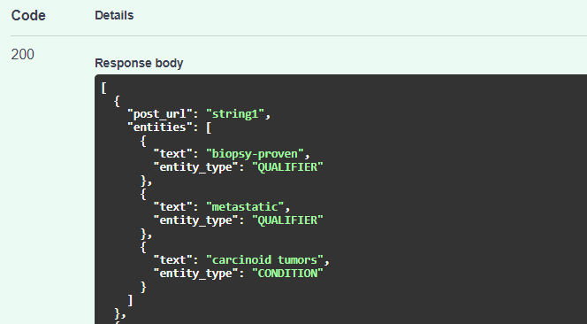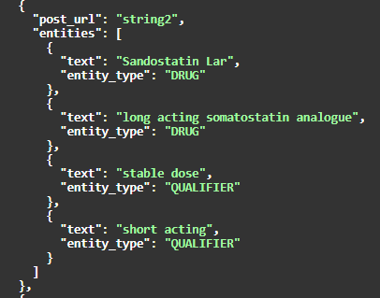

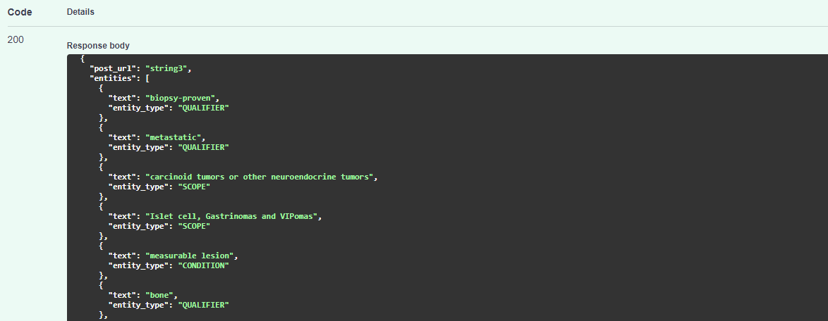

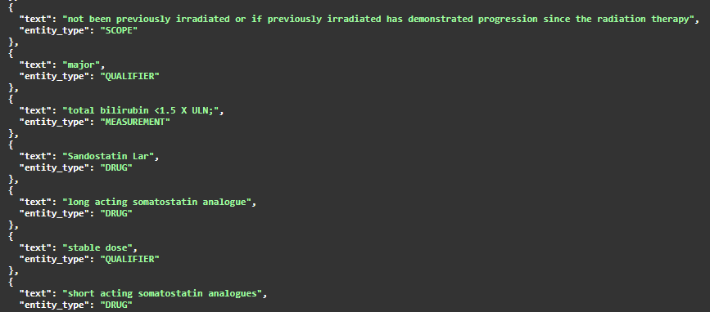 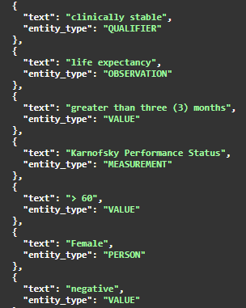 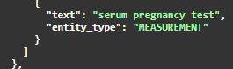

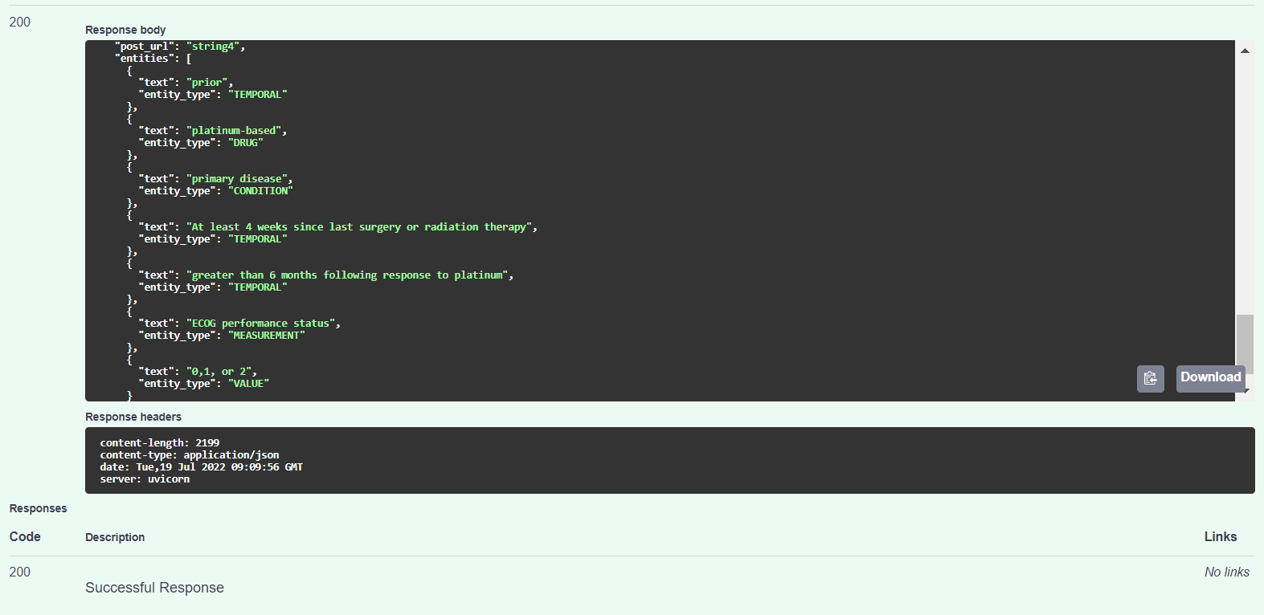

1. Test the POST query inside the POSTMAN tool.

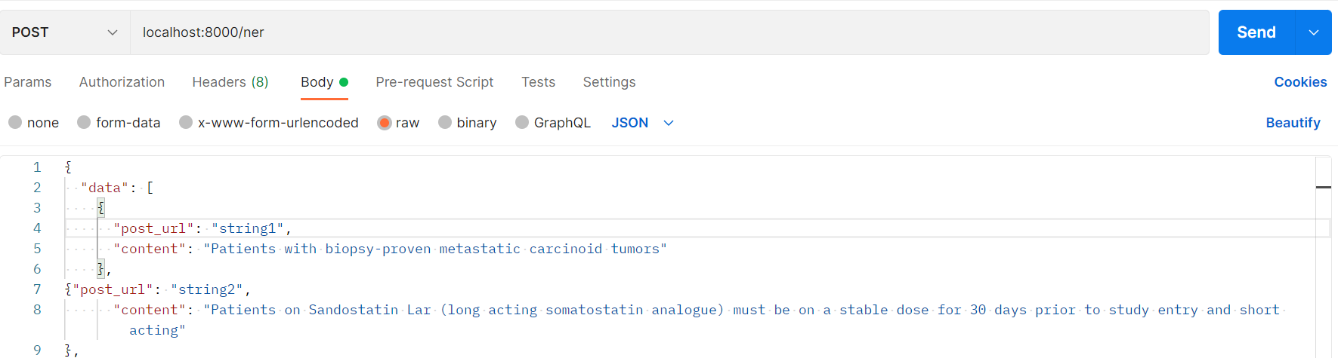

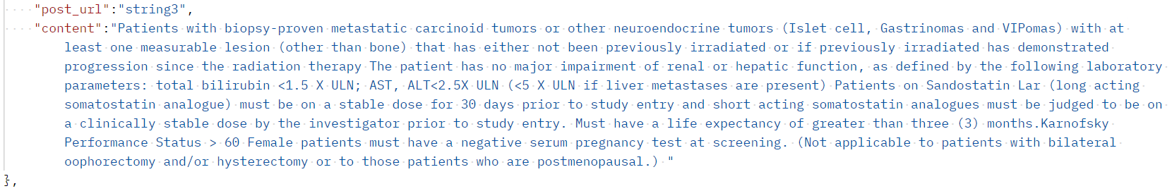

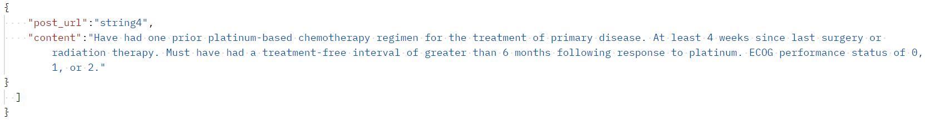

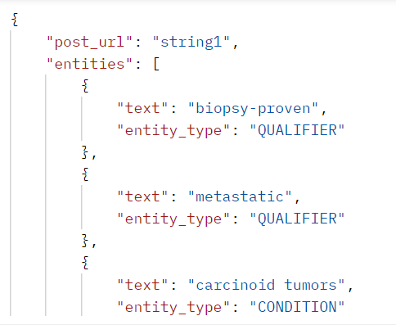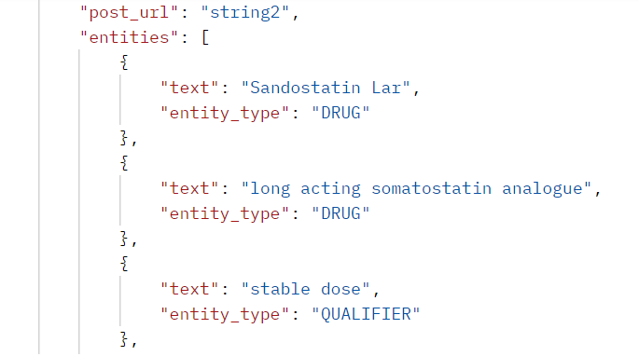

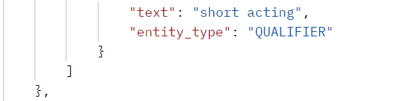

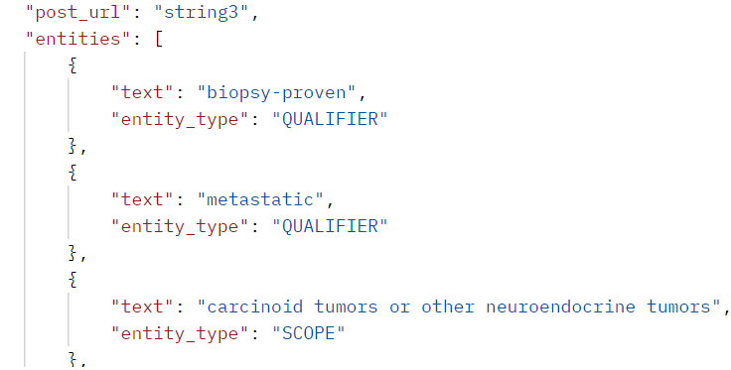

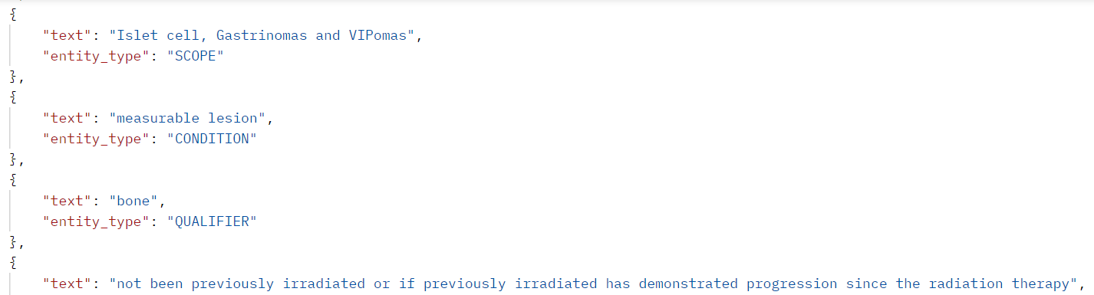

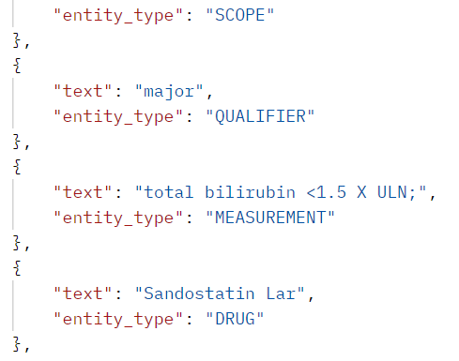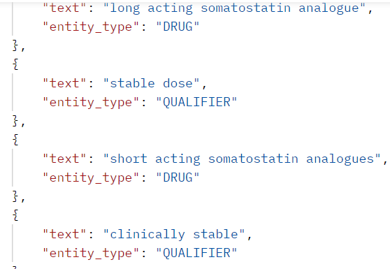

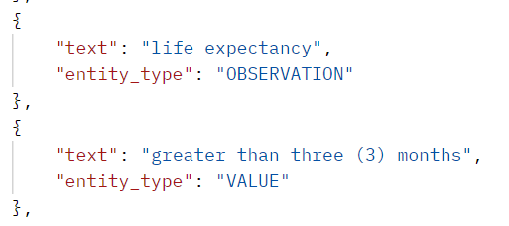

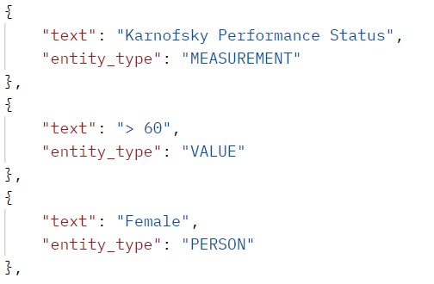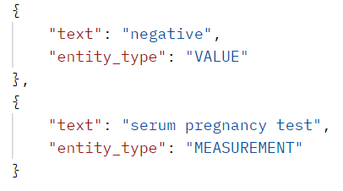

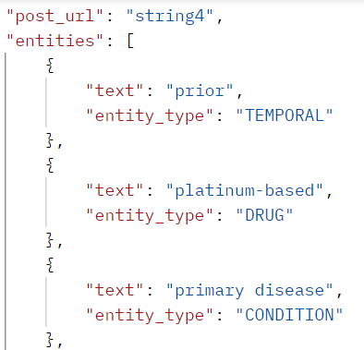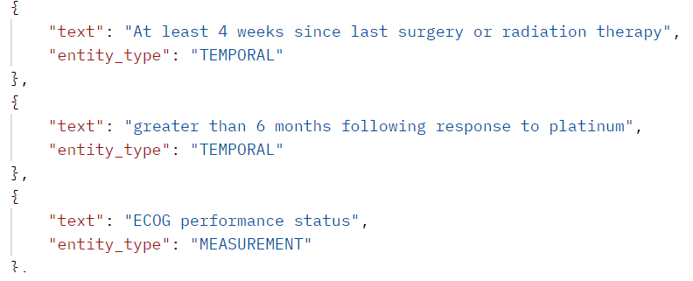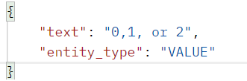

**Packaging your own SpaCy Model**

1. Create 2 folders models and packaged_models in **chia_clinical_trials\projects\tutorials\ner_pytorch_medical** directory.
2. Place the trained Chia NER model folder model-best inside the **models** directory
3. Inside command prompt, run the command: **python -m spacy package models/model-best packaged_models**
4. This creates the **en_pipeline-0.0.0** inside the **packaged_models** directory.
5. Traverse to the directory **packaged_models/ en_pipeline-0.0.0** and run the command: **python setup.py sdist**
6. It creates **dist** folder and inside it created **en_pipeline-0.0.0.tar.gz** file.
7. Traverse to **dist** folder and run the command: **python -m** **pip install** **en_pipeline-0.0.0.tar.gz**
8. It successfully installs the package of the trained Chia NER model.

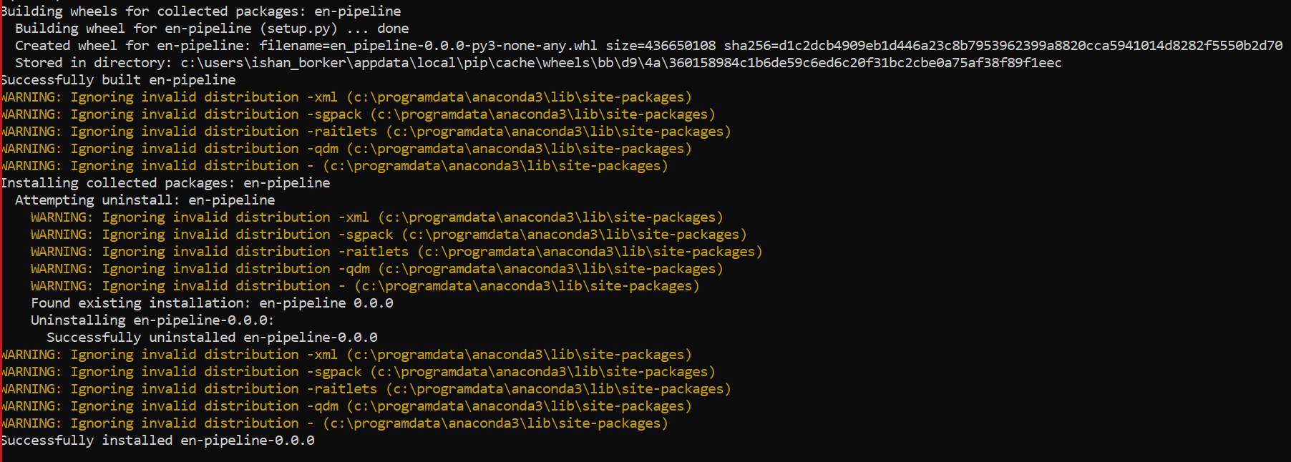

Inside Jupyter notebook,

1. Add the custom components and factories to SpaCy model. Create the custom component.
2. Load the base model ‘**en-pipeline-0.0.0**’ and analyze the pipes.
3. Add the component to the pipeline.
4. Test the pipeline.
5. Package the model using command:

**python -m spacy package test_chia_ner_pipe compiled --code chia_ner_component.py**

**Packaging NER and REL Model inside the VM**

1. **NER Model**:
2. Login inside the VM using the command: ssh root@10.53.97.117.
3. Create 2 folders models and packaged_models in /workspace/bionlp_poc/ml_soa directory inside the VM.
4. Place the trained Chia NER model folder output_roberta_7_ner inside the **models** directory.
5. Inside the output_roberta_7_ner directory, open the meta.json file and edit **"name":"chia_ner_pipeline_trf".**
6. Inside git bash terminal, run the command: **python -m spacy package models/output_roberta_7_ner** **packaged_models**
7. This creates the **en_chia_ner_pipeline_trf-0.0.0** inside the **packaged_models** directory.
8. Traverse to the directory **packaged_models/en_chia_ner_pipeline_trf-0.0.0** and run the command: **python setup.py sdist**
9. It creates **dist** folder and inside it created **en_chia_ner_pipeline_trf-0.0.0.tar.gz** file.
10. Traverse to **dist** folder and run the command: **python -m** **pip install** **en_chia_ner_pipeline_trf-0.0.0.tar.gz**
11. It will successfully install the trained Chia NER spacy model inside the system.
12. Validate it using the command: **python -m spacy validate**.
13. **REL Model**:
14. Login inside the VM using the command: ssh root@10.53.97.117.
15. Create 2 folders models and rel_models in /workspace/bionlp_poc/ml_soa directory inside the VM.
16. Place the trained Chia REL model folder chia_roberta_5_rel inside the **models** directory.
17. Inside the chia_roberta_5_rel directory, open the meta.json file and edit **"name":"chia_rel_pipeline_trf".**
18. Inside git bash terminal, run the command: **python -m spacy package models/chia_roberta_5_rel** **rel_models - -code list of comma separated custom component .py files.**

**e.g.** 1. python -m spacy package models/chia_roberta_5_rel/ rel-models/ --code scripts/rel_pipe.py, scripts/rel_model.py

2. python -m spacy package chia_roberta_5_rel/ rel_models/ --code chia_roberta_5_rel/rel_pipe.py, chia_roberta_5_rel/rel_model.py

1. This creates the **en_chia_rel_pipeline_trf-0.0.0** inside the **rel_models** directory.
2. Traverse to the directory **rel_models/en_chia_rel_pipeline_trf-0.0.0** and run the command: **python setup.py sdist**
3. It creates **dist** folder and inside it created **en_chia_rel_pipeline_trf-0.0.0.tar.gz** file.
4. Traverse to **dist** folder and run the command: **python -m** **pip install** **en_chia_rel_pipeline_trf-0.0.0.tar.gz**
5. It will successfully install the trained Chia REL spacy model inside the system.
6. Validate it using the command: **python -m spacy validate**.

(**Note**: Perform the pip install of REL model inside the Command prompt only).

**CTO Portal NER Results:**

1. Once we run Flask code chia_app_new.py code, it will start the Chia Clinical Trials card present in Knowledge Graph inside the CTO Portal.



1. We upload any one of the Inc/Exc text file of Chia dataset and click on submit. It displays the following results:
2. **Inc/Exc Criteria**: The text of patients details present in the uploaded file.

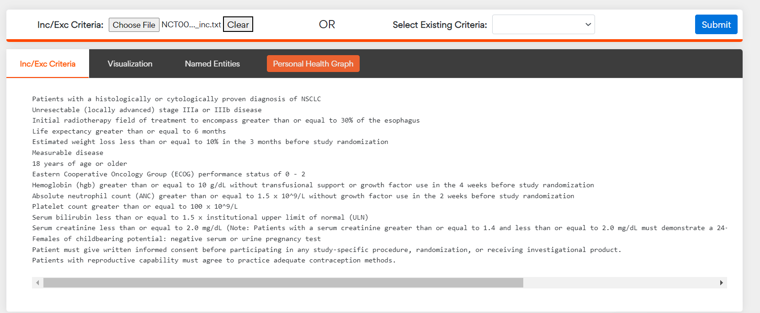

1. **Visualization**: It shows the annotations carried out on the text and displays top 10 entities.

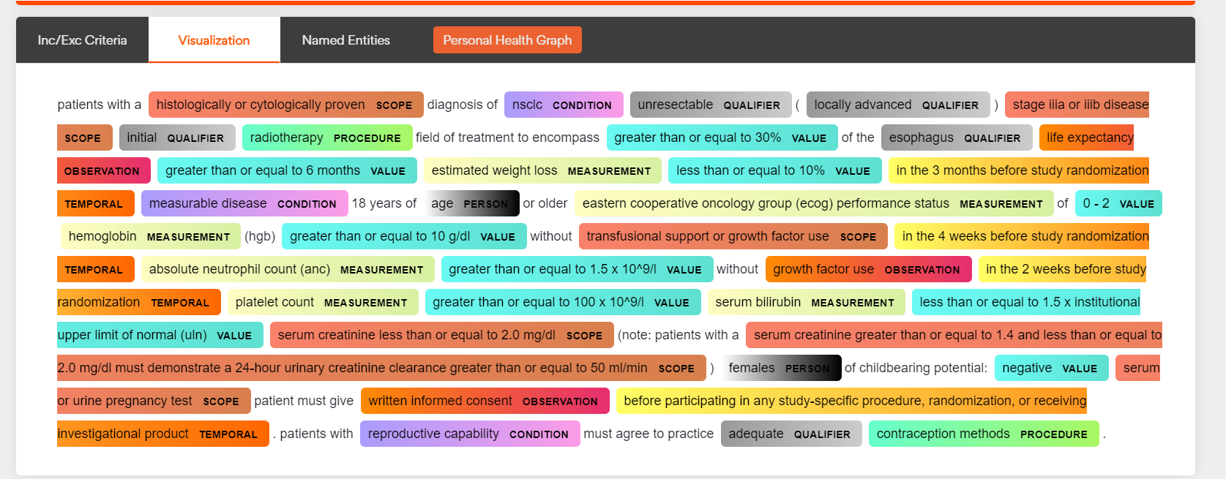

1. **Named Entities**: It displays concept, concept type(entities) and UMLS (Unified Medical Language System) normalized text and the CUI (Concept Unique Identifier) value in a tabular format.

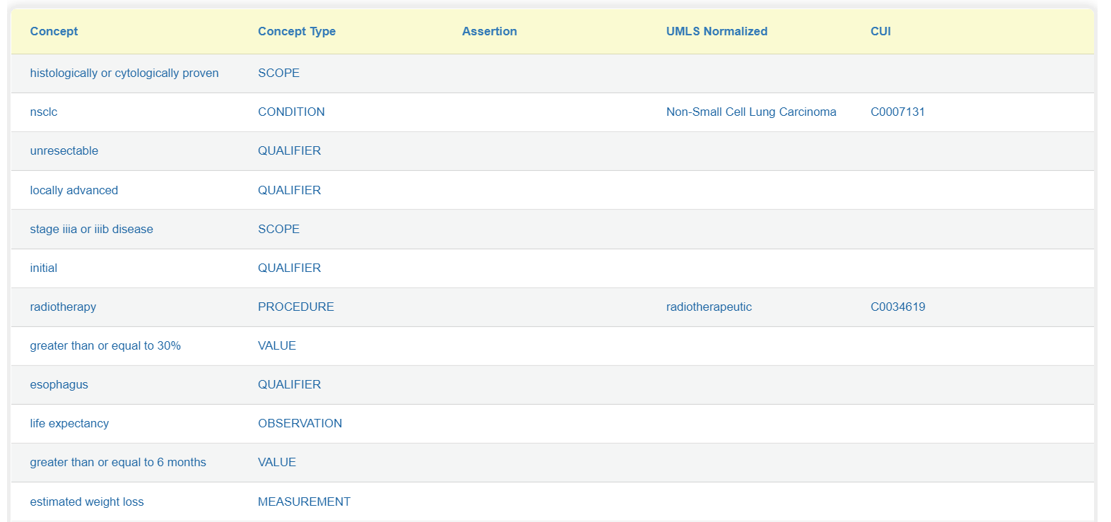

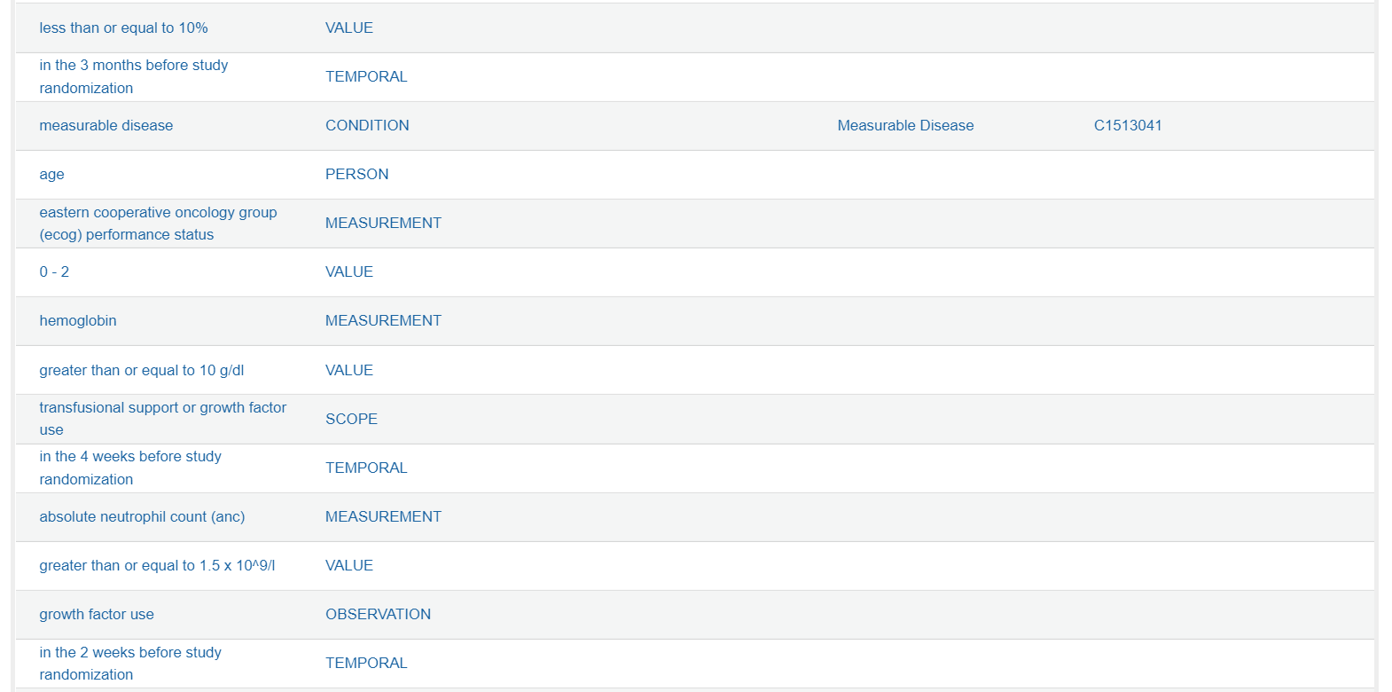

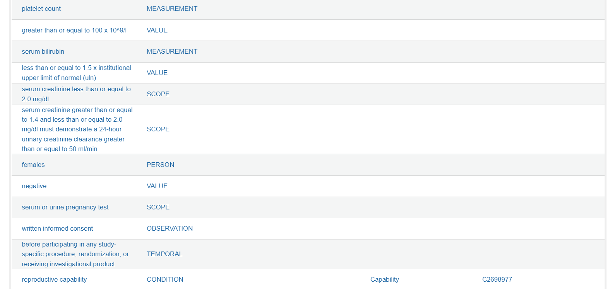

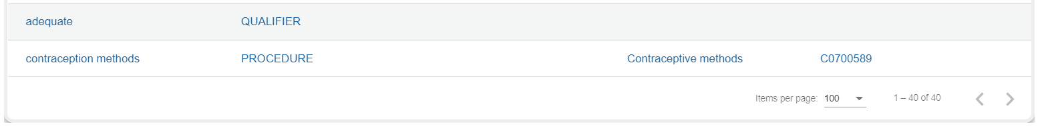

1. **Personal Health Groups**: It displays the results of relations extracted in a graphical format.

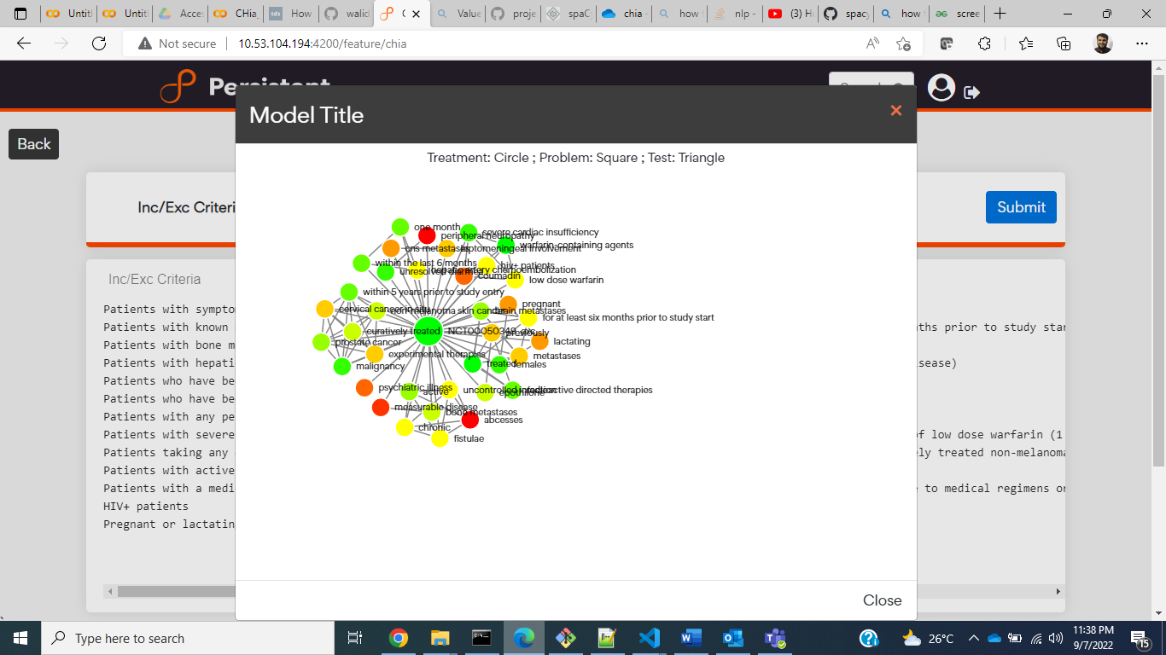

**Dockerize the Fast API application and eploying the FastAPI code inside the Amazon EC2 T2 medium instance**

1. Create an SSO account in AWS and inside it creates an Amazon EC2 T2 medium instance (Ubuntu VM).
2. Generate Key pair .pem file FastAPI_new.pem, download it in the local system and place it inside the FastAPI_NER_Deployment.
3. Open the gitbash terminal and traverse through the directory FastAPI_NER_Deployment.
4. Use the command **chmod 400 FastAPI_new.pem**
5. Use the command **ssh -i "FastAPI_new.pem" ubuntu@ec2-35-93-58-234.us-west-2.compute.amazonaws.com** to connect to the EC2 instance (ubuntu VM). (Public ipv4 of EC2 will change once we start the instance again)
6. Create a directory named Desktop inside the ubuntu VM.
7. Create the Dockerfile inside the FastAPI_NER_Deployment as follows:

**FROM python:3.8.14-slim**

**RUN apt-get update**

**WORKDIR /app**

**COPY . /app**

**RUN pip3 install torch>=1.6.0 --no-cache-dir**

**RUN python3 -m pip install en_chia_ner_pipeline_trf-0.0.0.tar.gz**

**RUN pip3 install -r requirements.txt**

**# RUN python3 -m spacy download en_core_web_sm**

**# RUN python3 -m pip install en_chia_ner_pipeline_trf-0.0.0.tar.gz**

**EXPOSE 8000**

**ENTRYPOINT ["uvicorn", "main:app", "--host", "0.0.0.0", "--port", "8000","--reload"]**

**# CMD ["uvicorn","main:app","--reload"]**

It contains all the required packages along with the spacy models.

1. FastAPI_NER_Deployment which contains Dockerfile, main.py, FastAPI_new.pem, requirements.txt, en_chia_ner_pipeline_trf-0.0.0.tar.gz inside the app directory and the ner_pytorch_medical directory which has NER model along with the pipelines.
2. There are also two sub- directories inside ner_pytorch_medical named models and packaged_models.
3. The models directory contains our saved NER model.
4. The packaged_models directory contains the packaged spacy model.
5. Install the spacy_transformers.
6. Follow the same steps for packaging the spacy models inside the ubuntu VM as mentioned above.
   1. Traverse to the directory packaged_models/en_chia_ner_pipeline_trf-0.0.0/ and run the command: **python3 setup.py sdist**
   2. Traverse to the directory dist/ and use the pip install command to install our spacy model: **python3 -m pip install en_chia_ner_pipeline_trf-0.0.0.tar.gz**
   3. Validating the spacy models using the command: **python3 -m spacy validate**
7. Copy the FastAPI_NER_Deployment directory into the ubuntu VM using the command:

**scp -i "C:\Users\ishan_borker\Desktop\FastAPI_NER_Deployment\app\FastAPI_new.pem" -r "C:\Users\ishan_borker\Desktop\FastAPI_NER_Deployment"** [**ubuntu@35.93.58.234:/home/ubuntu/Desktop**](mailto:ubuntu@35.93.58.234:/home/ubuntu/Desktop)

1. Install the miniconda inside the ubuntu VM using the commands:

**wget https://repo.anaconda.com/miniconda/Miniconda3-latest-Linux-x86_64.sh**

**chmod +x Miniconda3-latest-Linux-x86_64.sh**

**./Miniconda3-latest-Linux-x86_64.sh**

1. Create a new conda environment conda create –name fastapi_ner.
2. Install python3.8 using the command: **conda install -c anaconda python=3.8**
3. Traverse to the directory /home/ubuntu/Desktop/FastAPI_NER_Deployment/app and install the docker

**sudo apt install -y docker**

**sudo groupadd docker**

**sudo snap install docker**

**sudo apt install docker.io**

1. Build the docker image: **sudo docker build -t fastapi_ner:latest .**
2. Run the docker image: **sudo docker run -d --name ner -p 8000:8000 <Image_ID>**
3. Checking the status of docker: **docker ps -a**
4. Checking the logs: **docker logs <container_name>**
5. Checking if our FastAPI is running or not: **curl localhost:8000**
6. Install the nginx server: **sudo apt install nginx**
7. Change the files present using **sudo nano /etc/nginx/sites-enabled/fastapi-demo**

server {

listen 80;

server_name <Public_IPv4_EC2>;

location / {

proxy_pass http://127.0.0.1:8000;

}

}

1. **sudo nano /etc/nginx/sites-enabled/default**

server {

listen 80 default_server;

listen [::]:80 default_server;

root /var/www/html;

index index.html index.htm index.nginx-debian.html;

server_name;

location / {

try_files $uri $uri/ =404;

1. Inside the security groups in AWS management console of EC2 instance we specify the port number 80, source 0.0.0.0/0 and TCP protocol.
2. Start the nginx service: **sudo service nginx restart**
3. Check it’s status: **systemctl status nginx.service**
4. Go to the POSTMAN application and click on new HTTP request.
5. Test GET request as <Public_Ipv4_address_of_EC2>:80 and click on send button.

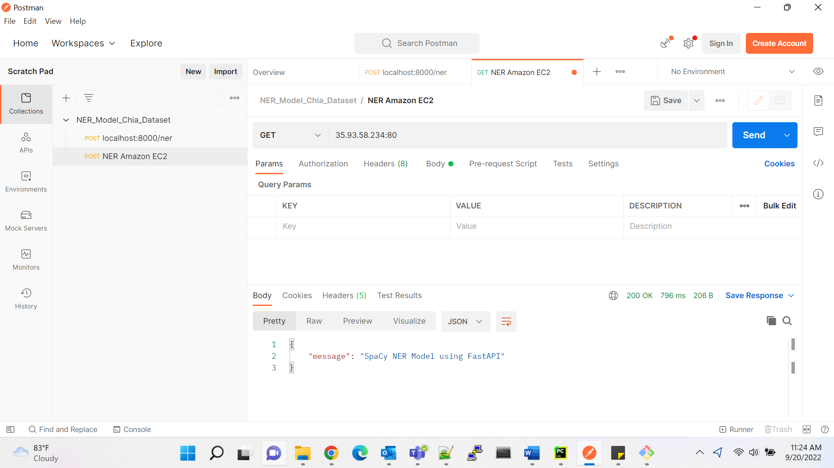

1. For the POST request, enter the input of the entire text in the body (raw-text) and type as JSON.

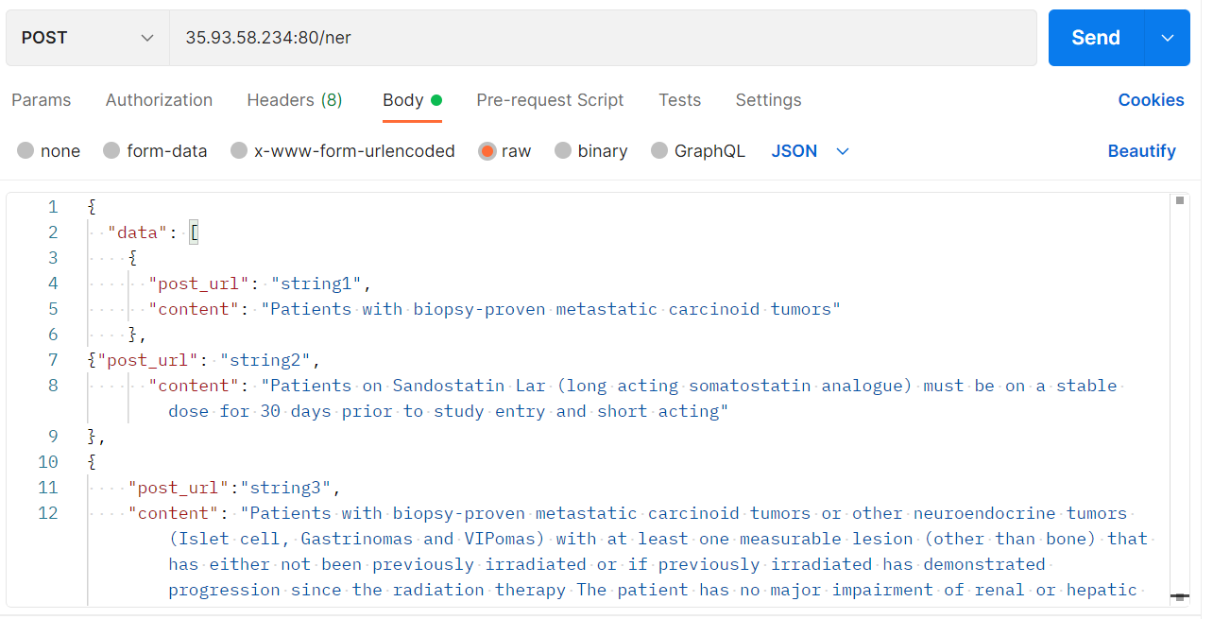

1. Test the POST request as <Public_Ipv4_address_of_EC2>:80/ner and click on send button.

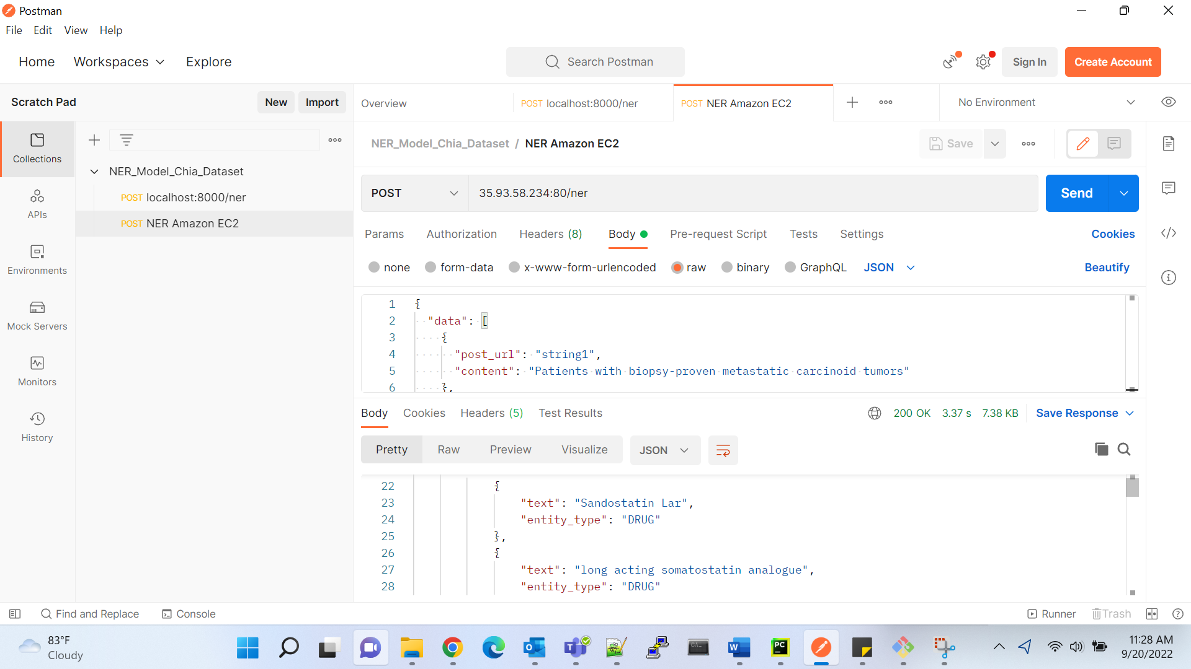

1. Test the same POST request in FastAPI docs as <Public_Ipv4_address_of_EC2>:80/docs.

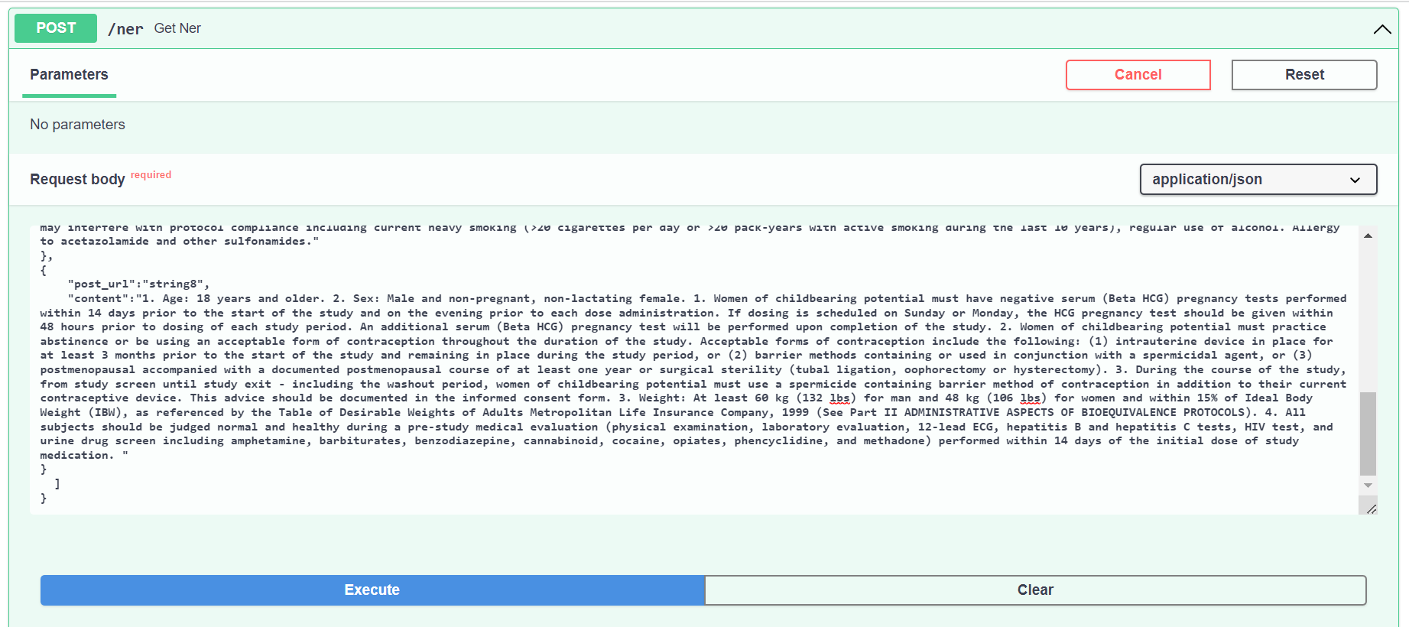

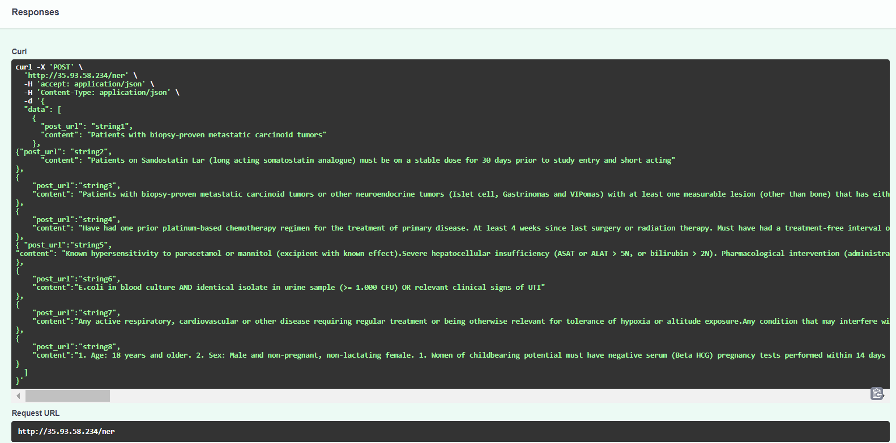

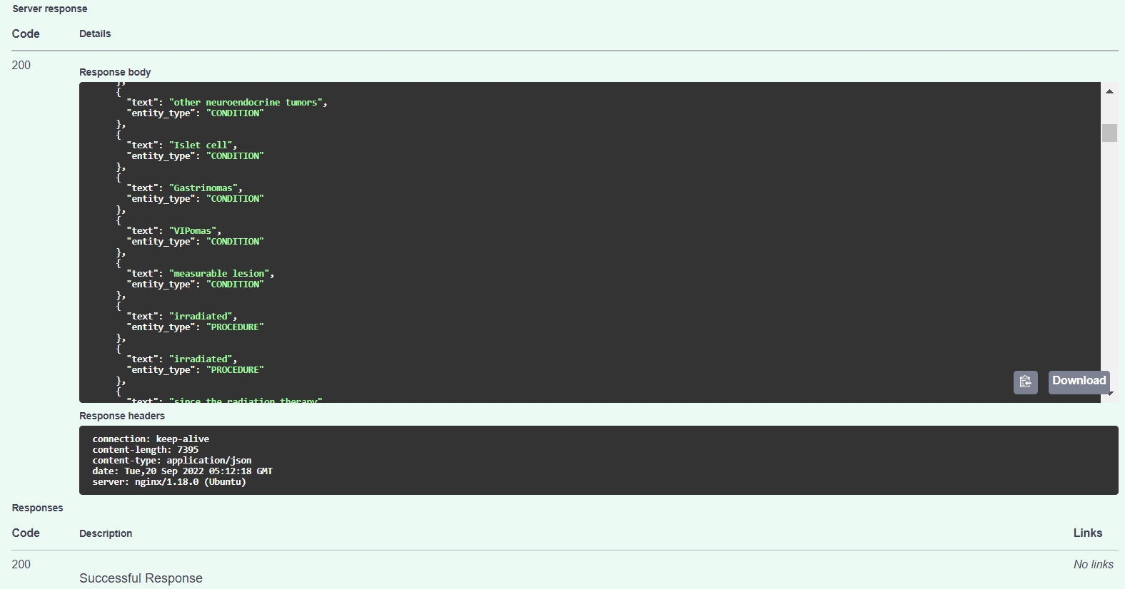

**Pushing the docker container code of FastAPI NER model inside the GitHub repository**

1. Create a GitHub account and create a repository inside it named FastAPI_NER.
2. After creating the repository, click on code and select the link to clone the repository inside the Ubuntu VM using the command: **git clone** [**https://github.com/ish0205/FastAPI_NER.git**](https://github.com/ish0205/FastAPI_NER.git)
3. Create a folder inside the VM named git_repository and push the code of FastAPI inside home/ubuntu/git_repository/FastAPI_NER.

**cp -r /home/ubuntu/Desktop/FastAPI_NER_Deployment/app/ /home/ubuntu/git_repository/FastAPI_NER/**

1. Traverse inside the home/ubuntu/git_repository/FastAPI_NER directory and perform the following git operations:

**git add .**

**git commit -m “First commit”**

**git push origin**

1. This will push the entire docker container code of FastAPI NER model inside the GitHub repository.

**Questions**:

1. Does it have all the sentences?

Ans) It has covered most of the sentences.

The total number of lines present in **train.bio**: 137,418, **test.bio**: 31,727, **dev.bio**: 28,948.

For REL, it has covered 102 training sentences from 43 articles, 27 dev sentences from 5 articles and 20 test sentences from 6 articles.



1. All annotated data is covered? if missed, how many?

Ans) Most of the data is annotated in the train, test and dev directories.

1. What's the reason we are missing those (if any)?

Ans) We are missing some of them due to Unicode error exception present in the **def** verify_textbounds(textbounds, text) function in standoff.py code (line 204).